**Link: -** <https://www.youtube.com/playlist?list=PLd3UqWTnYXOl_KwGTt4BZe2k3q2Yu3y1f>

**Mock:** [Programming Tutorials and Source Code Examples (java2s.com)](http://www.java2s.com/)

**Mock: paper and exam :** **http://www.java2s.com/**

**Exam Curriculum: - OCA**

**Duration: 150 minutes**

**Number of Questions : 70**

**Passing Score : 65% (Around 46 Questions you should answer)**

**Format: Multiple Choice**

**Java Basics**

* Define the scope of variables
* Define the structure of a Java class
* Create executable Java applications with a main method; run a Java program from the command line; produce console output
* Import other Java packages to make them accessible in your code
* Compare and contrast the features and components of Java such as: platform independence, object orientation, encapsulation, etc.

**Working With Java Data Types**

* Declare and initialize variables (including casting of primitive data types)
* Differentiate between object reference variables and primitive variables
* Know how to read or write to object fields
* Explain an Object's Lifecycle (creation, "dereference by reassignment" and garbage collection)
* Develop code that uses wrapper classes such as Boolean, Double, and Integer

**Using Operators and Decision Constructs**

* Use Java operators; use parentheses to override operator precedence
* Test equality between Strings and other objects using == and equals ()
* Create if and if/else and ternary constructs
* Use a switch statement

**Creating and Using Arrays**

* Declare, instantiate, initialize and use a one-dimensional array
* Declare, instantiate, initialize and use multi-dimensional arrays

**Using Loop Constructs**

* Create and use while loops
* Create and use for loops including the enhanced for loop
* Create and use do/while loops
* Compare loop constructs
* Use break and continue

**Working with Methods and Encapsulation**

* Create methods with arguments and return values; including overloaded methods
* Apply the static keyword to methods and fields
* Create and overload constructors; differentiate between default and user defined constructors
* Apply access modifiers
* Apply encapsulation principles to a class
* Determine the effect upon object references and primitive values when they are passed  into methods that change the values

**Working with Inheritance**

* Describe inheritance and its benefits
* Develop code that makes use of polymorphism; develop code that overrides methods;  differentiate between the type of a reference and the type of an object
* Determine when casting is necessary
* Use super and this to access objects and constructors
* Use abstract classes and interfaces

**Handling Exceptions**

* Differentiate among checked exceptions, unchecked exceptions, and Errors
* Create a try-catch block and determine how exceptions alter normal program flow
* Describe the advantages of Exception handling
* Create and invoke a method that throws an exception
* Recognize common exception classes (such as NullPointerException, ArithmeticException, ArrayIndexOutOfBoundsException, ClassCastException)

**Working with Selected classes from the Java API**

* Manipulate data using the StringBuilder class and its methods
* Create and manipulate Strings
* Create and manipulate calendar data using classes from java.time.LocalDateTime,  java.time.LocalDate, java.time.LocalTime, java.time.format.DateTimeFormatter, java.time.Period
* Declare and use an ArrayList of a given type
* Write a simple Lambda expression that consumes a Lambda Predicate expression

**OCJA = 1Z0-808**

**OCJP = 1Z0-809**

**Tutorial 1:**

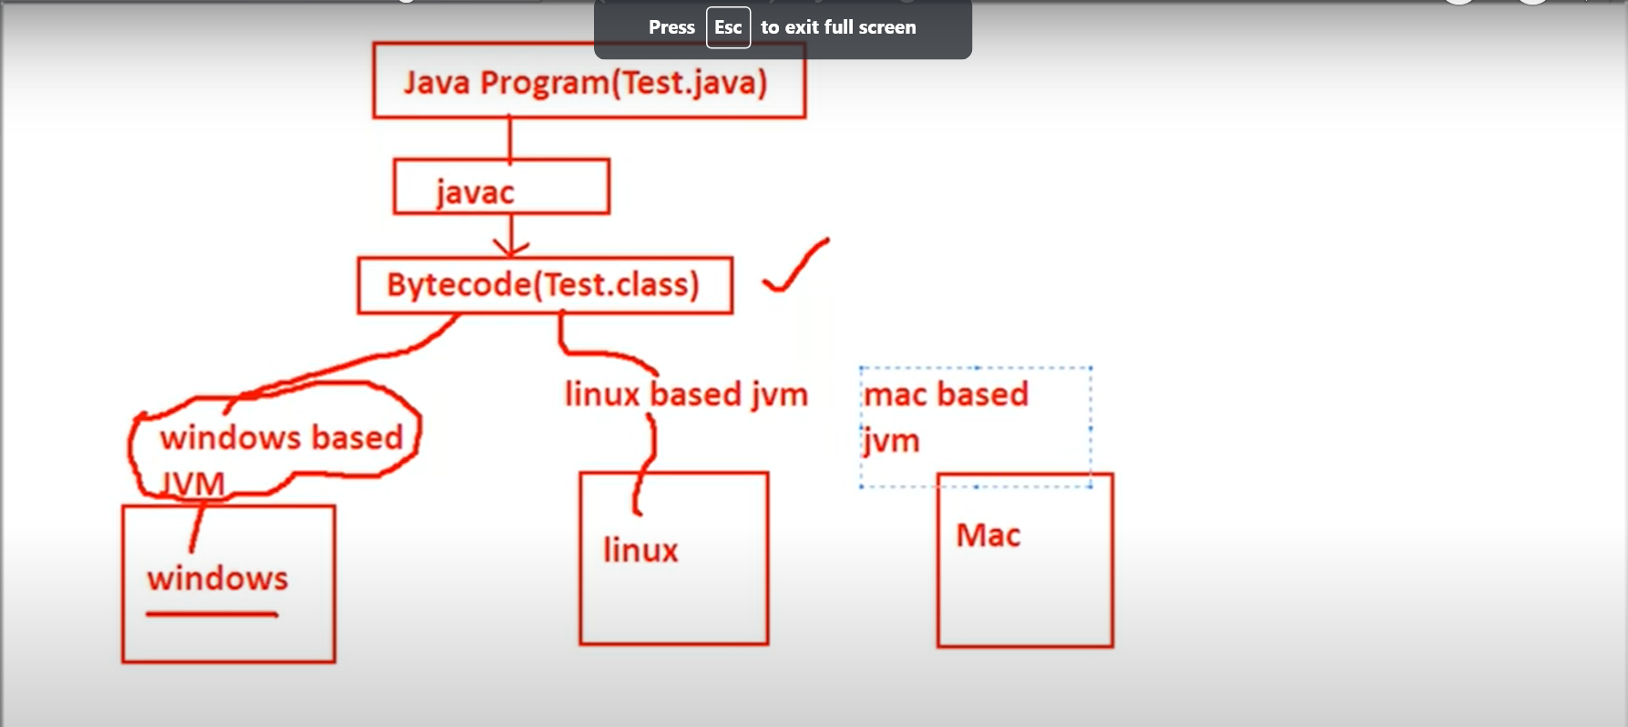

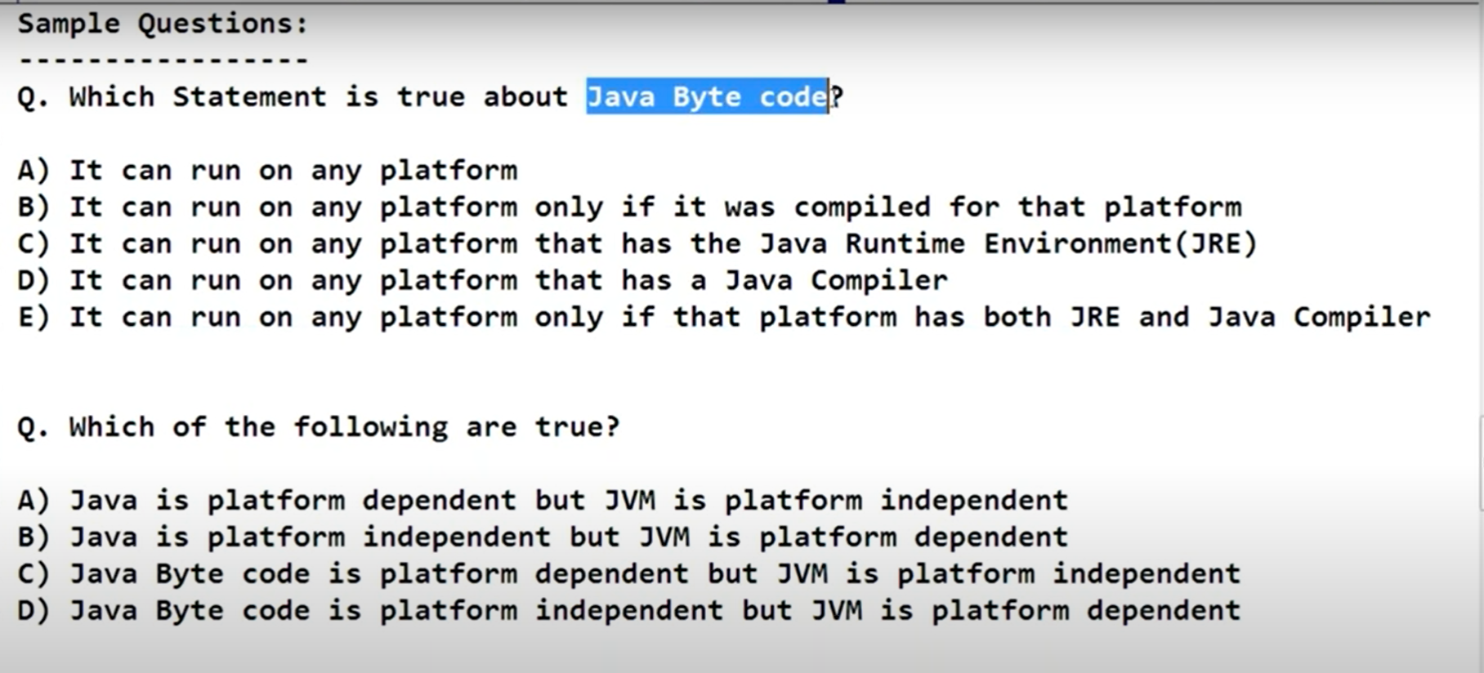

**Test.java 🡺 Test.class (compiler) 🡺 Bytecode 🡺 Machine Code (JVM)**

**Tutorial – 2**

Java Features (Java Buzzwords)

1. Simple
2. Secure
3. Portable
4. Object Oriented
5. Robust
6. Multi Threaded
7. Architecture Neutral
8. Interpreted
9. HighPerformance
10. Distributed
11. Portable
12. Dynamic

Simple –

* Secure:

**Test.java 🡺 Test.class (compiler) 🡺 Bytecode 🡺 Machine Code (JVM)**

Inside JVM : Bytecode Verifier + Security Manager

Sandbox Checking

* Object Oriented – interms of object

Encapsulation - Security

Inheritance - Reusability

Polymorphism – Flexibility

* Robust – The chance of failing is very very rare.

Type checking: Strongly Typed PL

Garbage Collector 🡺 memory related problem is very rare

* Exception Handling:

Try

{}

catch(Exception e)

{}

* Platform Independent

Write once and run anywhere (WORA)

* Architecture Neutral

**Tutorial 3: - Nothing in it**

**Tutorial 4: -**

Buzz Words:

Platform independent – write once and run anywhere

Java Source file 🡺Test.java

Java Compiler 🡺 javac 🡺Test.java

ByteCode🡺 Test.class

Byte code is platform independent code.

**Note: .class file contains byte code and .class file obtain after compiling the .java file**

**.class file is platform independent and .class file pass to jvm to create a machine code which is platform dependent.**

**Java – platform independent**

**Byte code - platform independent**

**JVM - platform dependent**

**JDK vs JRE vs JVM**

**JDK(java development kit)**

To develop and run java applications.

**JRE (Java Runtime Environment)**

To run java applications

**JVM (Java Virtual Machine)**

Interpreter to run our java program line by line

JDK – user for development and run which contains JRE and development tools

JRE – use for just run contains JVM and library classes

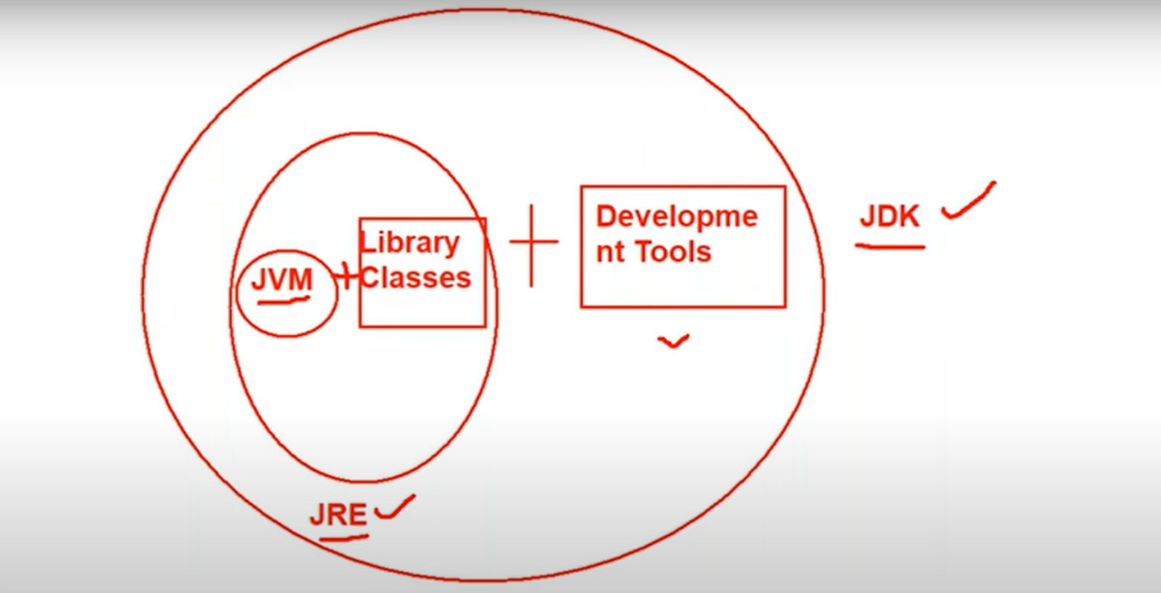

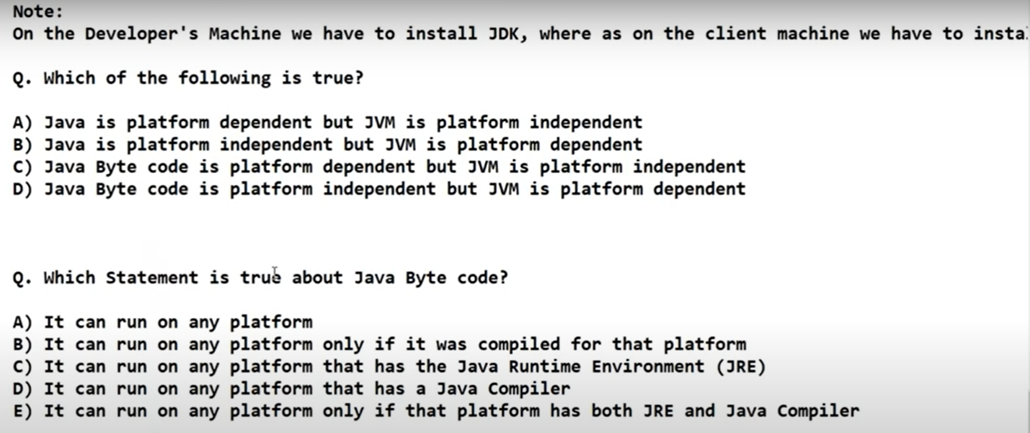

Answer:

* 1. B and D
  2. C only

**Java Features:**

Data Types And Literals

GOTO – 31.21

Note: - Strong Type Programming Language – means it check the data type very strongly

Java is Pure OOP?

No. because it support Primitive data type

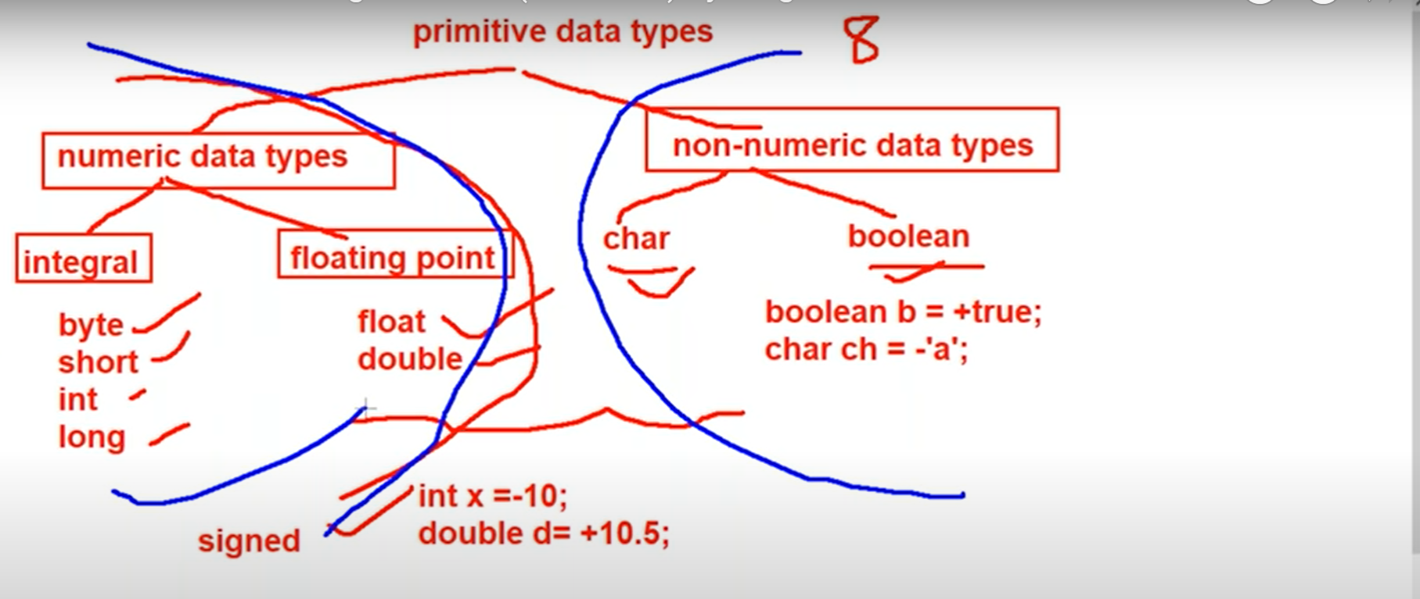

**Signed data types** = integral (byte, short, int, long) floating data types(float double)

**Non - Numeric data types** = char Boolean

Numbers:

* 1. Integral data Types – 10,20,10000

Byte, short , int, long

* 1. Floating point types

Float and double

Non Numeric Data Types:

Char and Boolean

‘a’, ‘@’

**Tutorial -5**

Byte:

Size = 1 byte(8 bit)

+127 to -128 -128 represent in the 2’s complement form

GOTO – 48.05

Char data type

Char ch = ‘a’

Java is Unicode

>256 < 65536

Boolean data type:

True, false

**Byte = 1 byte**

**Short = 2 byte**

**Int = 4 byte**

**Long = 8 byte**

**Float = 4 byte**

**Double = 8 byte**

**Char = 2 byte**

**Boolean = NA**

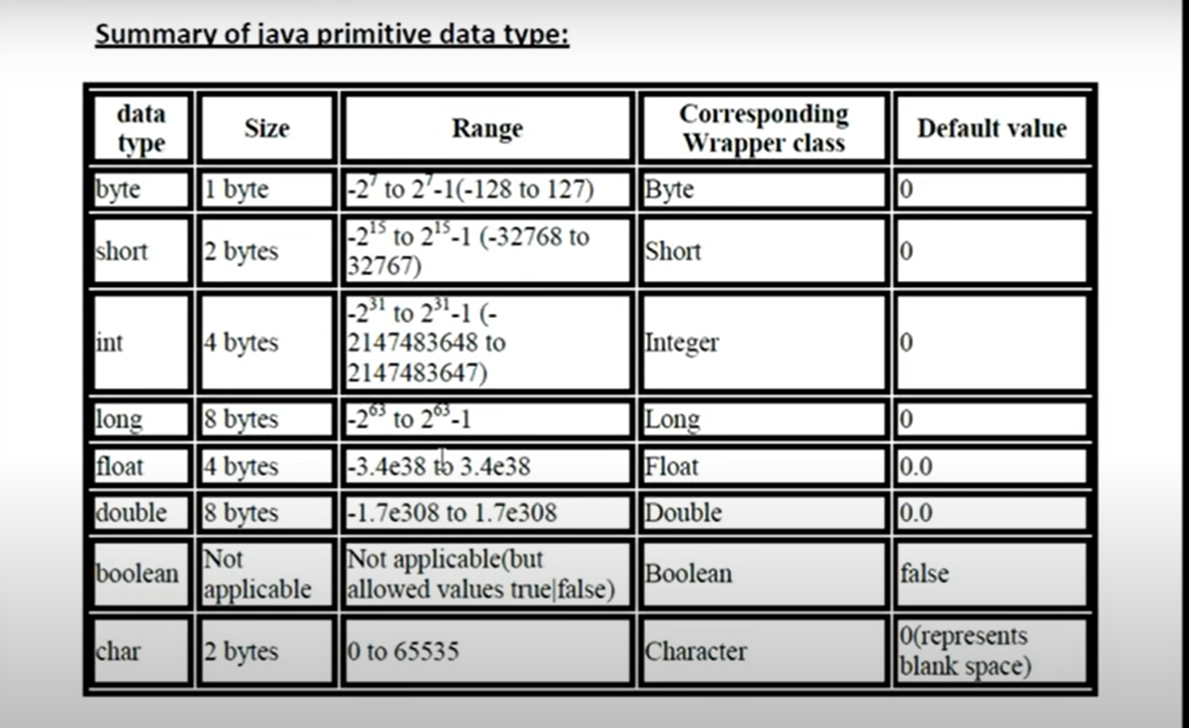

**Tutorial 6:**

Literals: - constant value assigned to the variables

Int x = 10; // 10 is literals

Way to provide literal to integral data types

* 1. Decimal (base-10)
     1. to 9

int x = 12

* 1. Octal(base -8)
     1. to 7

int x = 010 –

Note: it must start with 0 – zero

* 1. Hexa Decimal (base - 16)
     1. to 9, a to f

Note: case sentivity does not matter while writing hexadecimal value

Int x = 0x10; hexadecimal value must start with 0x or 0X

Which conversion are valid

Int x = 10; - valid

Long l = 10; -valid

Long l = 10L - valid

Int x = 10L; - invalid

**Note: there is no way to assign explicitly a byte type or short type.**

**Byte b = 100b; - invalid**

**Short s = 100s; - invalid**

Whenever we assign integral literal to the byte variable under the range of byte variable it assign it the byte type or

**Floating point literals:**

By default, every floating type literal is double type (8 byte)

Float f = 123.456 - invalid

Double d = 1234.456 - valid

Float f = 123.456f - valid

Double d = 123.456F - valid

Double d = 123.456D – valid

**Note: floating point literal only accept decimal, hexadecimal and octal can’t be assigned to the floating point literals**

**In other case, integral literal, octal decimal and hexa can be assigned to integral literals**

double d = 123.456F – valid

double d = 0123.456F – invalid

double d = 0X123.456F – invalid

float f = 0XBeef ; valid because output of 0XBeef is integer and later integer could be assigned to floating literal

float f = 0XBeef.123 – invalid such combination could not proceed

Exponential form – it is always double

Double d = 1.2e3; 🡺 1.2*10^3 🡺 1.2*1000 🡺1200.0

Float f = 1.2e3 – invalid // exponential is always double

**Tutorial 7:**

//Float f = 1.2e3 – invalid // exponential is always double

**Note: int, short, long we can assign both value to the floating point literals i.e float and double**

Boolean:

In java Boolean value is just True and false and can’t be replaced with **1** or **0**

Boolean b = 0; - invalid // only allowed values are true or false

Sop(b);

While(1) - invalid

{

Sop(“Hello”); // Boolean can’t be replace with integer value for while loop

}

Char literals

Char ch = ‘a’ // must be inside single quote and only single character

*** Char ch = 97 // it will print the corresponding character till 65537

Char ch = 1972 // wil print ‘?’ because value is still not assigned to the particular Unicode

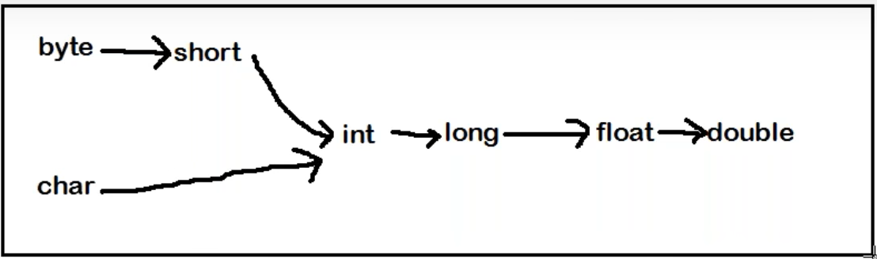

**Tutorial 8:**

//Char literals

**PRIMITIVE TYPE CASTING:**

* 1. Implicit type casting int x = ‘a’; double d = 10;
* Compiler
* Smaller data type value to bigger data type
* No loss of information
* Widening or upcasting
  1. Explicit type casting

Int x = 130;

Byte b = (byte) x ; // programmer is responsible for explicit type casting

Examples:

1. Which of the following conversion will be performed automatically in java ?

A ) int to byte - no

B) byte to int - yes

c) float to double - yes

D) double to float - not

e) None of the above

Q2. In which of the following case explicit type casting is required

1. Int to byte - yes
2. Byte to int - no
3. Float to double - no
4. Double to float - yes
5. None of the above

Q 3. Consider the code

Int I = 100;

Float f = 100.100f;

Double d = 123;

Which of the following assignment won’t compile?

1. I = f - no
2. f = I - yes
3. d = f - yes
4. f = d - no
5. d = I - yes
6. i = d - no

Q 4. In which of the following cases we will get compile time error ?

A. float f = 100F; - no

B. float f = (float)1_11.00; - no

C. float f = 100; - no

D double d = 203.22; -

Float d= d; yes compile time error

E. int I = 100;

Float f = (float) I; no

**Tutorial 9:**

**Array:**

//double d = 10;

An array is an indexed collection of fixed numbers of homogeneous data elements

Array declaration:

All below are allowed / valid

Int [] x;

Int []x;

Int x []

Int x [];

**Int [4] x; - not allowed at the time of declaration we are not allowed to specify the size.**

**All below are valid**

Int [][] x;

Int [][]x;

Int x [][];

Int [] []x;

Int [] x[];

Int []x[];

Int [] a, b; // a- 1D. b-1D

Int [] a, b [] ; // a- 1D. b-2D

Int [] [] a, b ; // a- 2D. b-2D

Int [] [] a, b [] ; // a- 2D. b-3D

**Note: if you want to specify dimension before variable this facility is only available for the first variable**

Int [] a, []b – invalid

Int [] a, b [] – valid

To get the class name

x.getclass().getName();

int [] 🡪 [I – for one dimension

int [][] 🡪 [[I for two dimensions

byte[] 🡪 [B

long [] 🡪 [L

Boolean [] 🡪 [Z

Int [] x = new int []; - invalid

Int [] x = new int [0]; - valid // array with zero size is legal - syntax wise

Class Test

{

Public static void main (String [] args)

{

}

}

Java Test A B C – **jvm is responsible for creation of string array**

**Note:**

Int x = new int [-3]; - invalid – negative value is not allowed

**import - Issue will be at the runtime or compile time ?**

**this is the issue at runtime time.**

because - new int[integer value] and -3 is integer value so compile time it will not give any error

at runtime when jvm allot a memory to array it give negative array size exception

**Tutorial 10:**

//at runtime when jvm allot a memory to array it give negative array size exception

Int []x = new int [‘a’]; // valid decleration

Int []x = new int [10L]; // invalid decleration // incompatible type … only integer value is allowed

double []x = new double [10D]; // invalid decleration // incompatible type … only integer value is allowed to declare integer

Int []x = new int [(int)10.5]; - valid

**2D Array:**

Array of Arrays concept

**Tutorial 11:**

//Array of Arrays concept

Array Initialization

**\*\*\* int [] x = new int [3]**

**Sop(x[0]); // 0**

Sop(x); **classname@hashcode_in_hexadecimalform** --> [1@1abb2dd

Once we create an array every element by default initializes with default value.

Int x= new int [3][2];

Sop(x); //[[1@hashcode

Sop(x[0]); // [I @hashcode

Sop(x[0][0]); //0

Array Decleration, Array Creation, Array Initialization

Int [] x ; // declaration

X = new int [3]; // creation

X[0] = 10; // initialization

X [1] = 20;

X[2] = 30;

Valid shortcut to reach

Int x = {10,20,30}; // shortcut

**Int []x;**

**X = {10,20,30} // invalid – all the decleration should be in single line for shortcut method**

Int [][]x = { {10,20,30}, {40,50}};

Sop(x[0][1]); //20

Sop(x[1][1]); //50

Sop(x[2][0]); //AIOOBE

**Length vs length() :**

Length – variable // size of the array

Length () – string // size of the string object

String [] s = {“A”,”AA”, “AAA”};

Sop(s.lengh); - valid

Sop(s.length()); // invalid

Sop(s[0].length); //invalid

Sop(s[0].length()); // valid

Int [][]x = new int [3][2];

Sop(x.length) //3 for multidimensional array length is always about the base size not the total size

Anonymous array – an array with the name

New int [] {10,20,30};

**Tutorial 12:**

**Allowed pattern**

String [] s = new String[10];

Object[] a = new Object[10];

A[0] = new Object[);

In the place of parent object array we can provide child object

**Not Allowed pattern**

String [] s = new String[10];

Object[] a = new Object[10];

s[0] = new Object[);

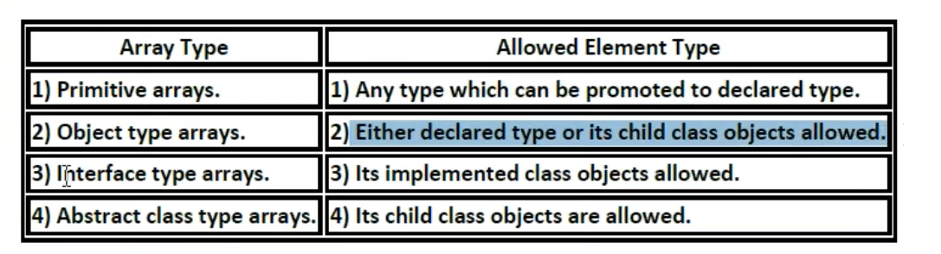

Interface type array

Runnable [] r = new Runnable[10];

**Runnable type array object** – class who has implemented runnable interface ..

R is the array of such classes

r[0] = new Thread ();

int []a = {10,20,30};

int []b = {40,50};

* 1. a=b // allowed
  2. b=a // allowed

sizes are not required to match but types must be matched

dimensions must be matched.

**Int x [][] = new int [3][2];**

**X[0] = new int [4]; - allowed one -** sizes are not required to match but types must be matched

And dimensions must be matched.

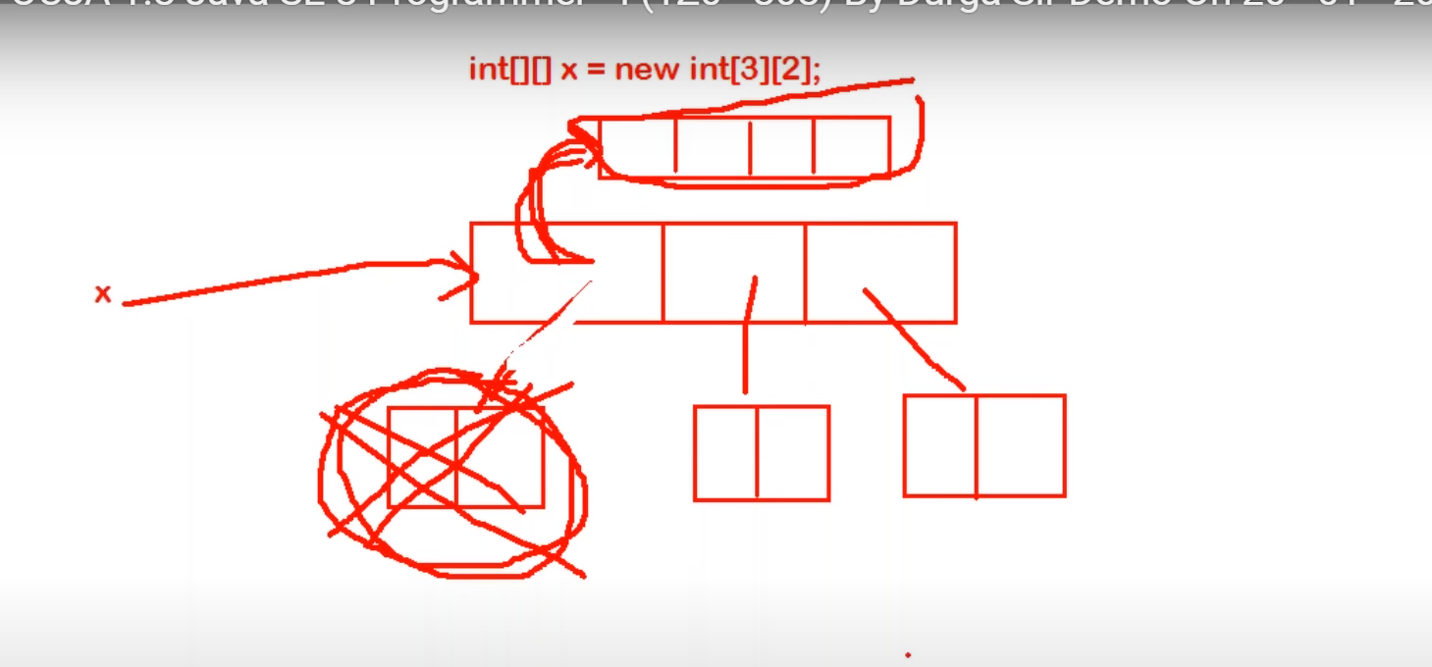

**String [] course = {“java”, “python”, “testing”, “sap”};**

**Sop(course.length)**

**Sop(course[1].length());**

* 1. **4,6**
  2. **6,4**
  3. **4,4**
  4. **6,6**

**Ans: a**

**Tutorial 13:**

Stundent [] student = {

New Student (101, “Durga”),

New Student (102, “Ravi”),

New Student (103, “Shiva”),

New Student (104, “Pavan”)

}

Sop(student) // [LStudent@6589

Sop(student[2]) // it point to student object and string method will be called student@hashcode

Sop(student[2].rollno); //103

Class Student

{

String name;

Public student (String name)

{

this.name = name;

}

}

**IMP:**

Public class Test

{

Public static void main (String [] args)

{

Student [] students = new Student[3];

Student[1] = new Student (“Durga”);

Student[2] = new Student (“Ravi”);

For(Student s : students)

{

System.out.println (s.name); // in the first loop value student object is null , so value of s.name as s do not have object it could not print the value of name , then it give null pointer exception.

}

}

}

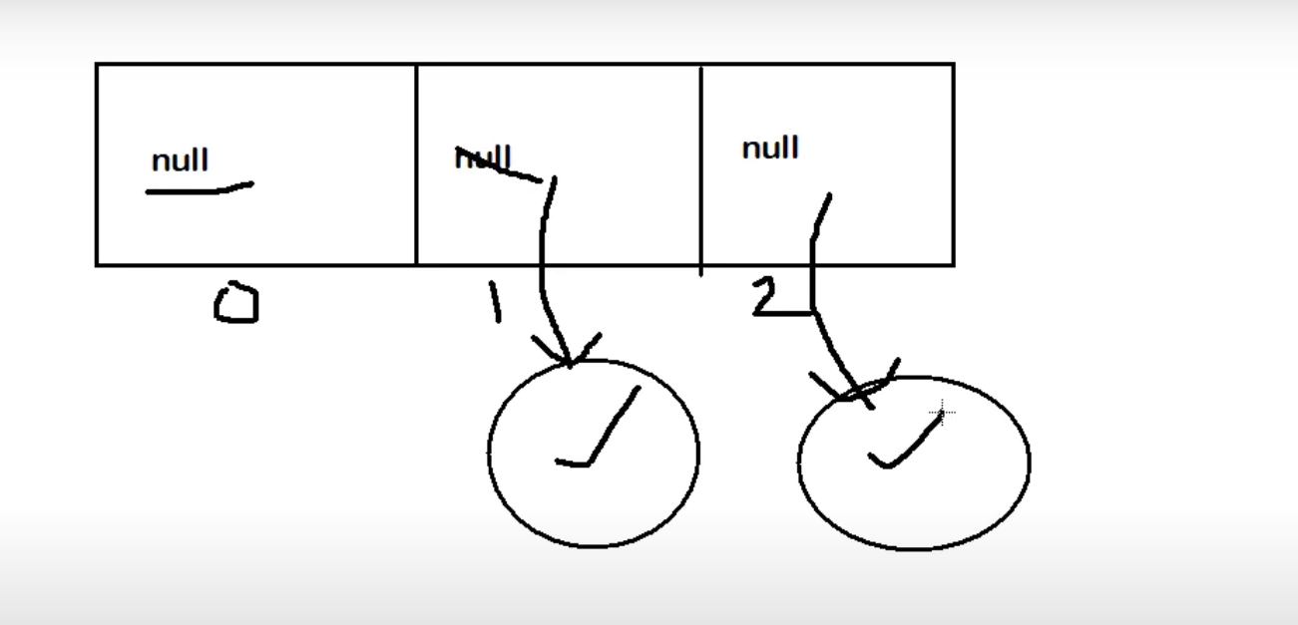

**Types of variables**

**Division 1:**

Based on Types of values represented by the variables

Types of variables

* 1. Primitive variables – refer to the primitive value

Int x, char c, double d – 8 primitive data types variables is primitive variables

* 1. Reference variables – refers to the object

String s = “Durga”;

Student s1 = new Student (“Durga”, 101);

**Division 2:**

Based on behaviour and position of variable

* 1. Instance
* If the value of variable varied from object to object such type of variable is called instance variable
* For every object new copy of instance variable will be created
* Instance variables must be created within class and outside of the method and constructors.
* From static area we can not allow to use instance area directly
* No need to perform initialization for instance variable, it comes with default value
  1. Local
  2. Static
* No need to perform initialization for instance variable, it comes with default value

GOTO: - 1:00:00

How to execute class

1. JVM will be started
2. Create and start main thread by JVM
3. Main thread will search for Test.class 🡺 NoClassDefFoundError
4. Main Thread will load Test.class
5. Executed main method
6. Unload Test.class file
7. Terminated Main Thread
8. JVM will be shutdown

**Tutorial 14:**

JVM will be shutdown

Int x = 10;

Static y – 20;

Psvm

{

Test t1 = new Test();

T1.x = 888;

T1.y=999; // static variable can be accessed using object - valid

Test t2 = new Test();

Sop(t2.x + “***”+ t2.y) //10 *** 999

}

***

Int x = 10;

Static y – 20;

Psvm

{

Test t1 = null;

// (T1.x) // can’t access value of x as object is null;

Sop(T1.y); // static variable can be accessed using object - even though value of object is null is value is 20 - valid

Sop(t2.y + “***”+ t2.x) // 20 followed by null pointer exception

}

//Note: Local variable initialization is compulsory

Psvm

{

Int x;

Sop(“hello”);

}

We get compile time error, because initialization is not done for the x as x is local variable

Psvm

{

Int x;

If(args.length > 0)

{

X = 10;

}

Sop(“hello”);

}

Here if if loop not work then x will not be initialized then

So every time it will compile time error.. as x is not initialized

Psvm

{

Int x;

If(args.length > 0)

{

X = 10;

}

Else

{

X = 20;

}

Sop(“hello”);

}

Here x is always compiling then the value is always provided.

**Tutorial 15:**

Here

// static can be used for inner class but not for class

Class Test

{

Static int x = 10;

Public static void m1() // static method is class level method no object is required to access it

{

}

}

Class Test

{

Class Inner

{

}

}

Test.Inner I = new Test().new Inner(); // inner class without static

Test.Inner I = new Test().Inner(); // static inner class

Int x = 10;

Public static void m1()

{

Sop(x); // under static method we are not allowed to access the instance variable

}

Public void m2()

{

}

**Note:**

**For static method implementation or body is compulsory**

**Abstract method syntax is not allowed for static method.**

Class Test

{

Public static void m1()

{

// here body is must otherwise compiler give error

}

}

Public abstract static void m1(); // illegal combination of modifier static can’t be abstract

Import question solve it on ide

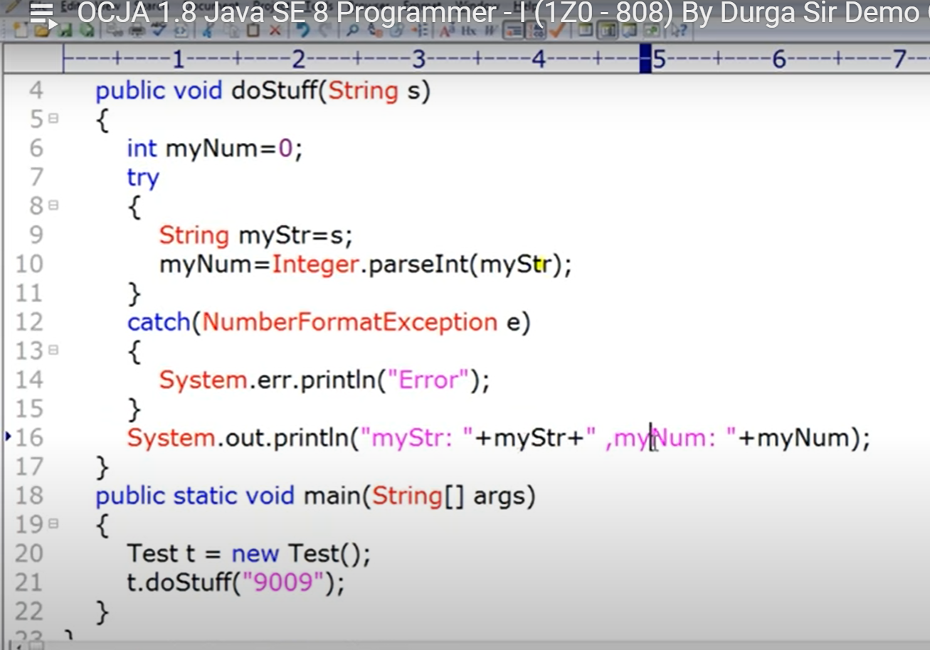

Import question must solve

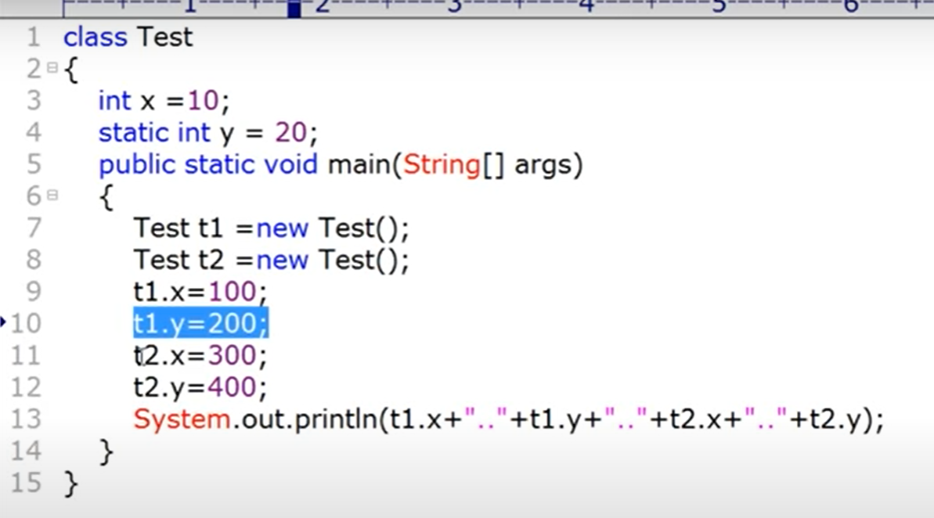

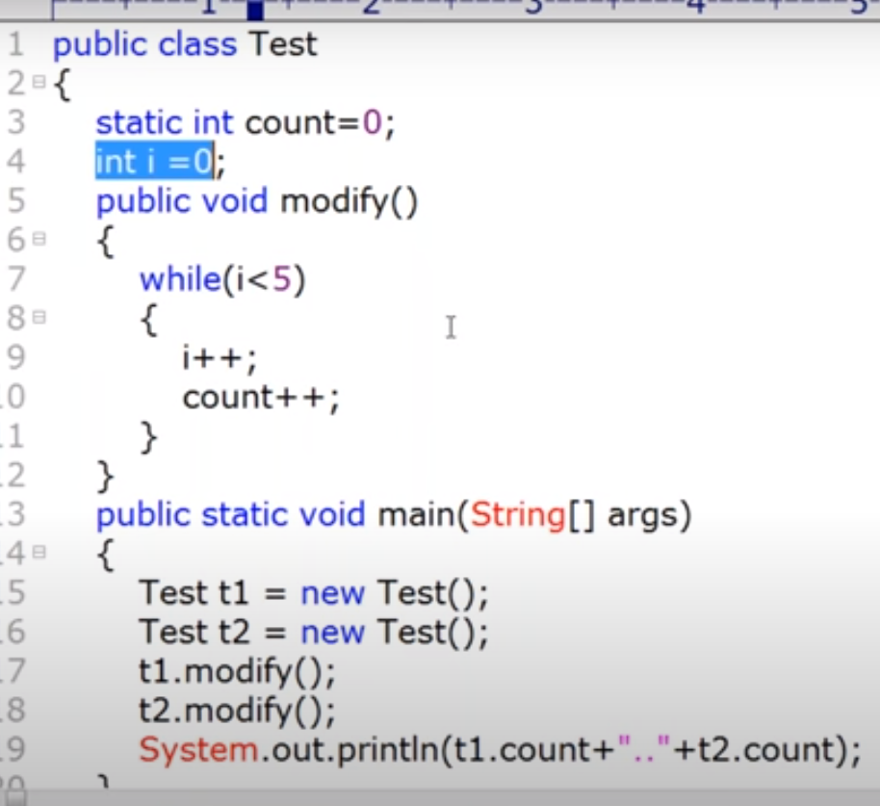

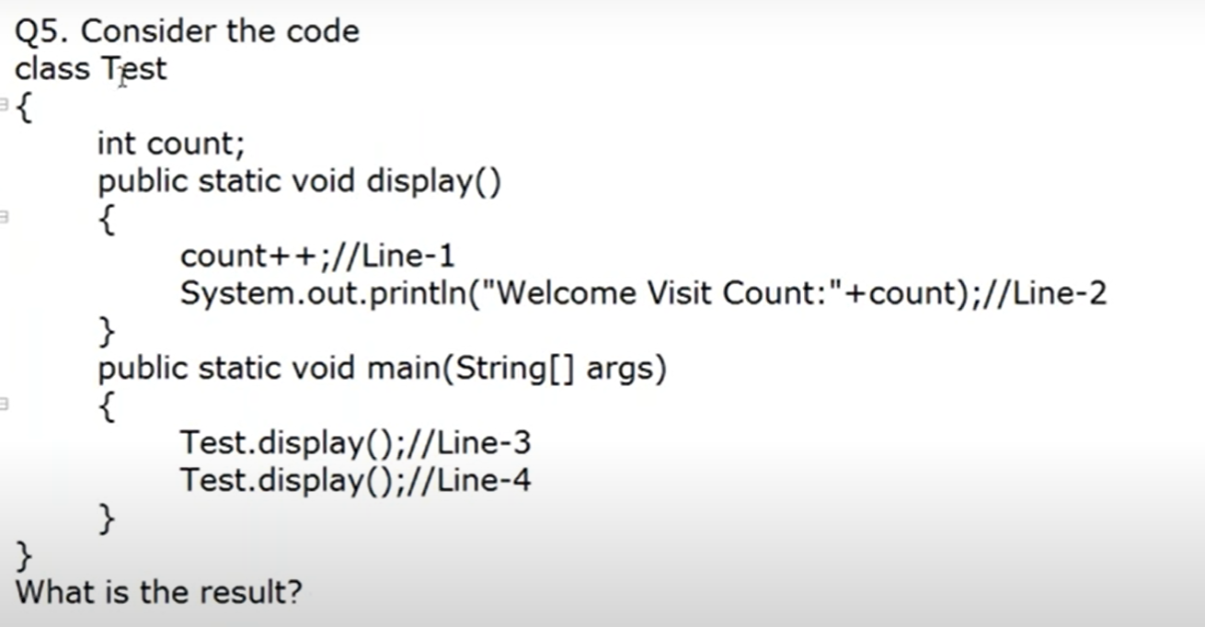

Compile time error at line 1 and line 2

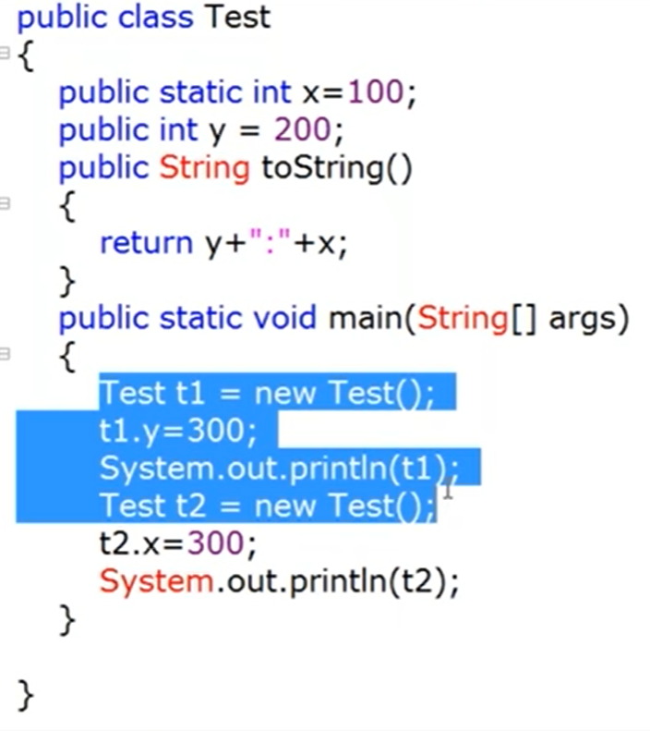

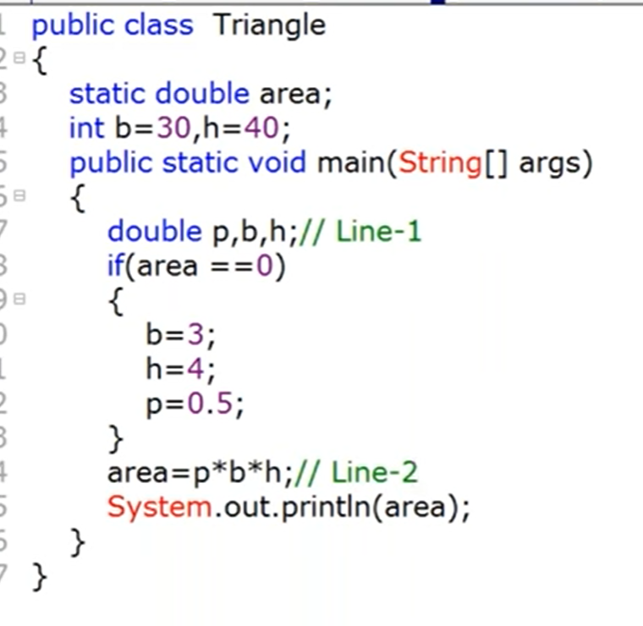

Compile time error

Class Demo

{

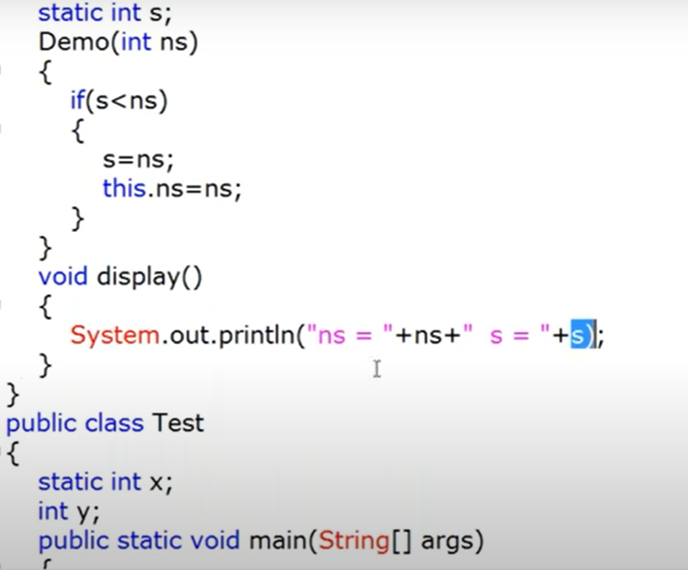

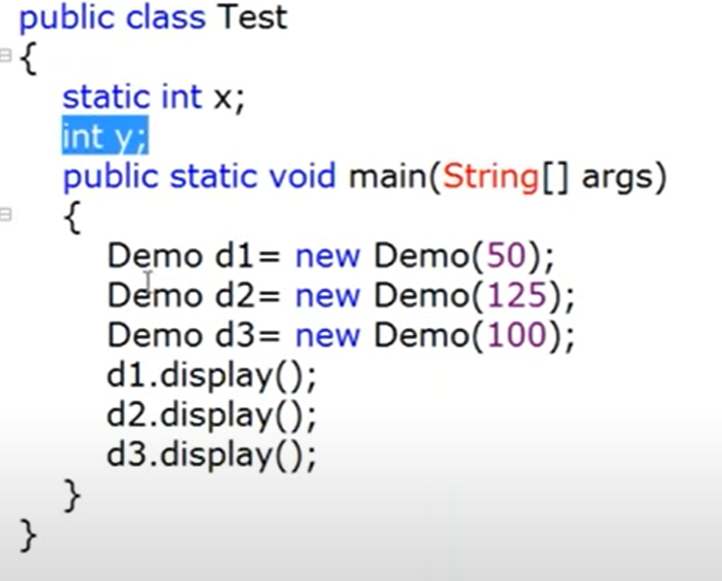

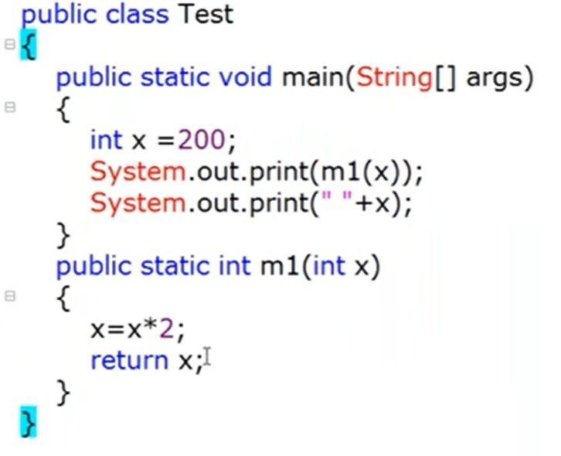

**Most-Important Questions**

**\*\*\*\*\*\*\***

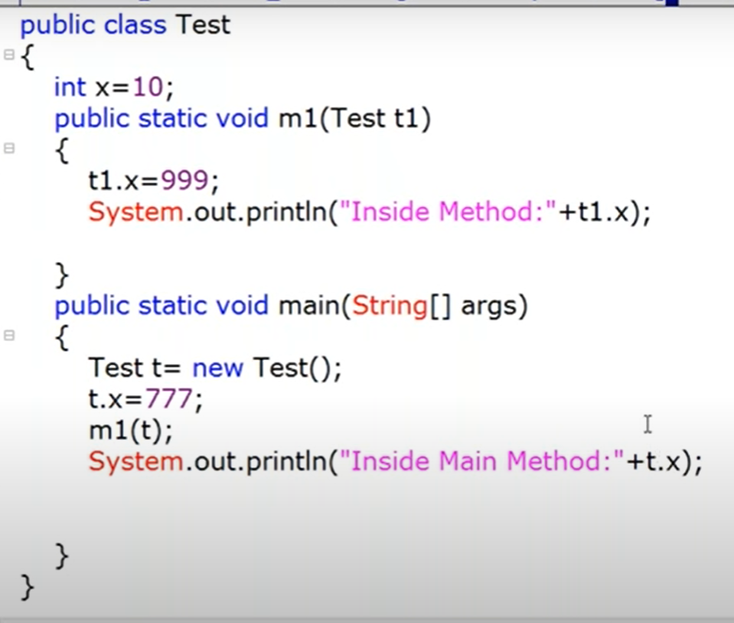

GOTO: 1.:04:00

// here we are passing object to the method , so object reference will be there, so method will make changes in the same object. That’s why value changes in the original object

Inside method - 999

Main Method – 999

// java all follow call by value and not call by reference

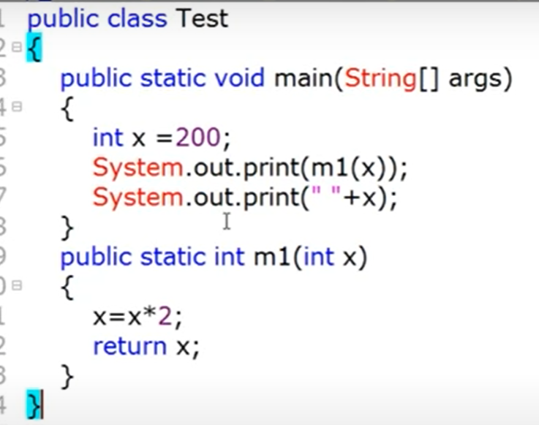

400

200

**Tutorial 16:**

200

Parameter passing

Primitive variable - > method - > change is not reflecting to to caller

Int x = 10;

M1(x);

Sop(x); //10

Reference variable 🡺

M1 (Test t)

{

t.x = 777; // if you pass any object reference as an argument , if we are changing the content or state of the object whose changes will reflected in the caller.

}

Test t1 = new Test();

Sop(t1.x); 10

M1(t1); // there may be a chance of changing the value in the method

sop(t1.x);

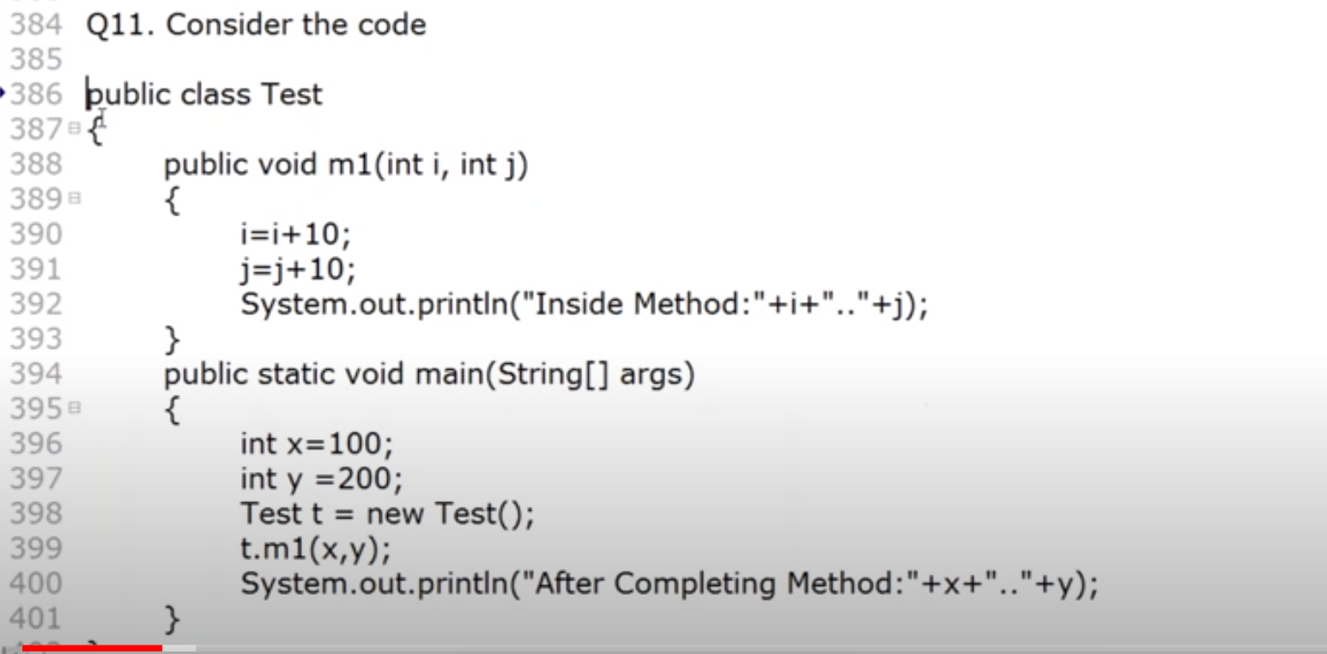

Inside method : 110 210

Main method: 100 200

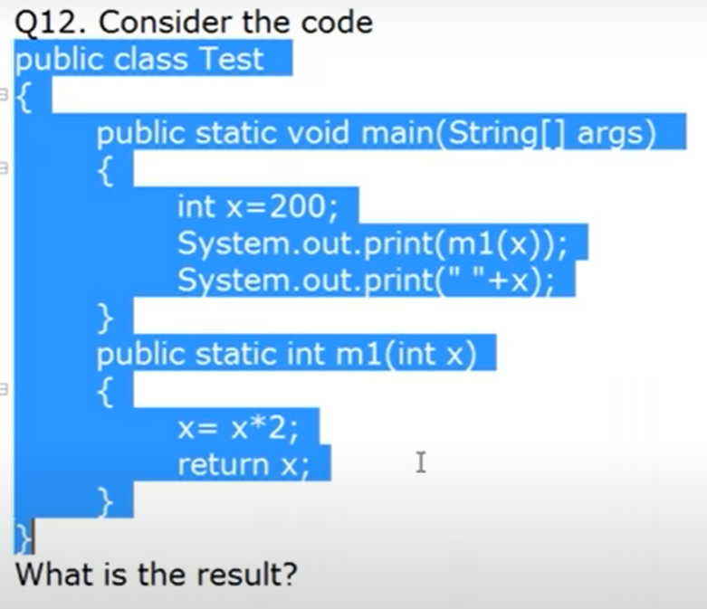

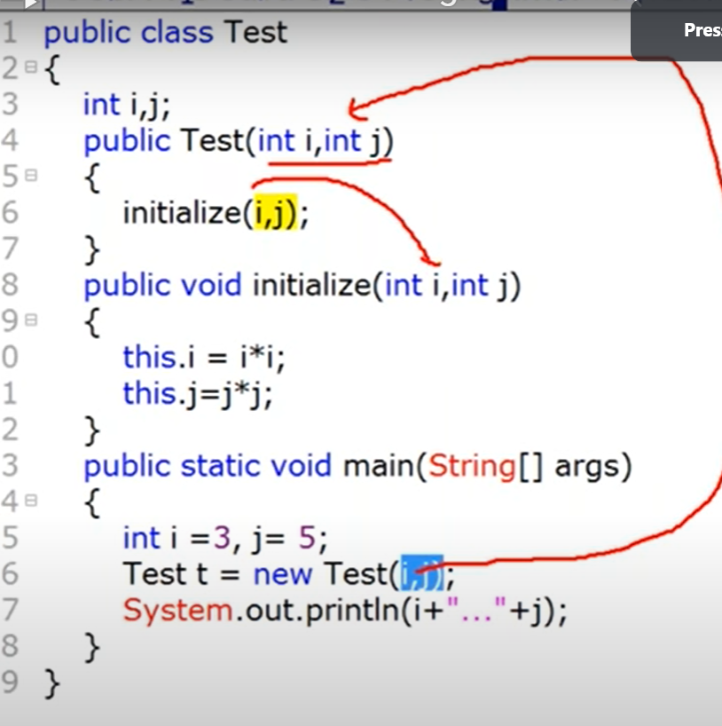

I=3, j=5;

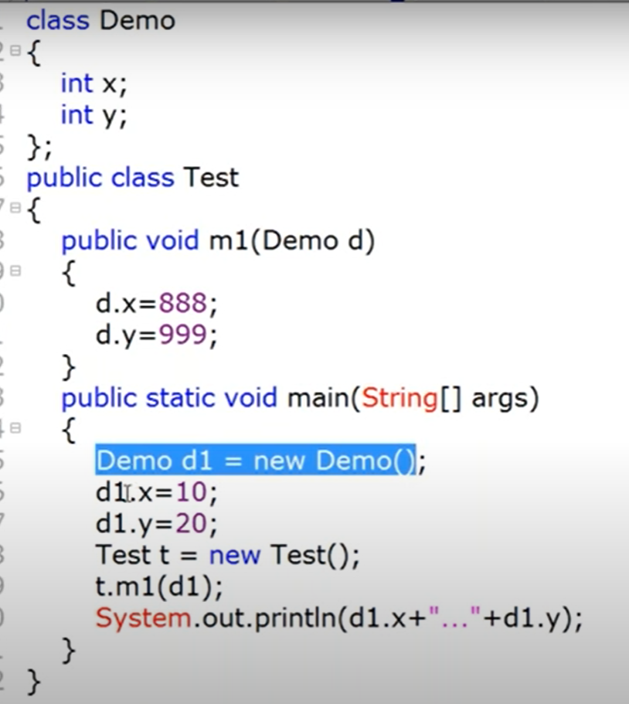

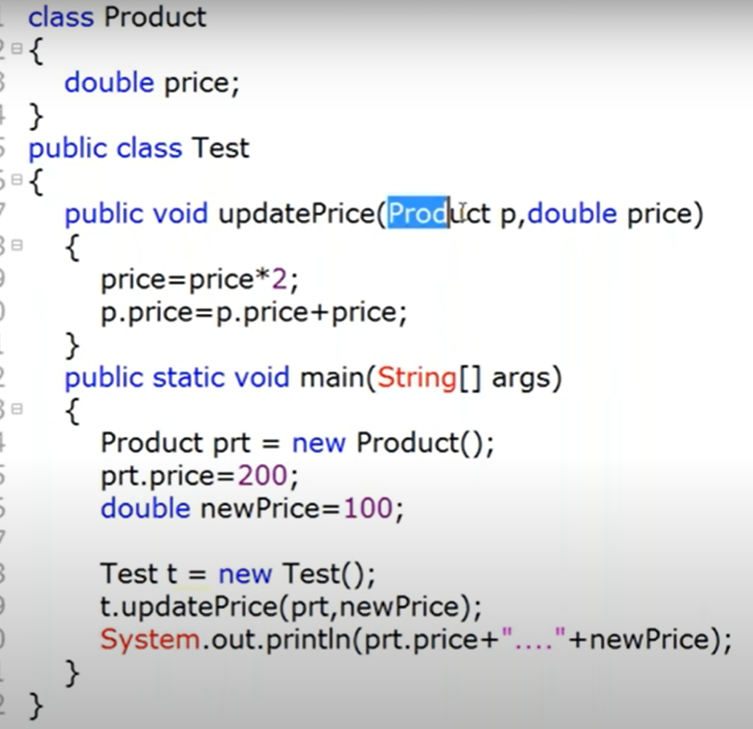

Prt.price = 200

NewPrice = 100

Price = 200;

200+200

400 100

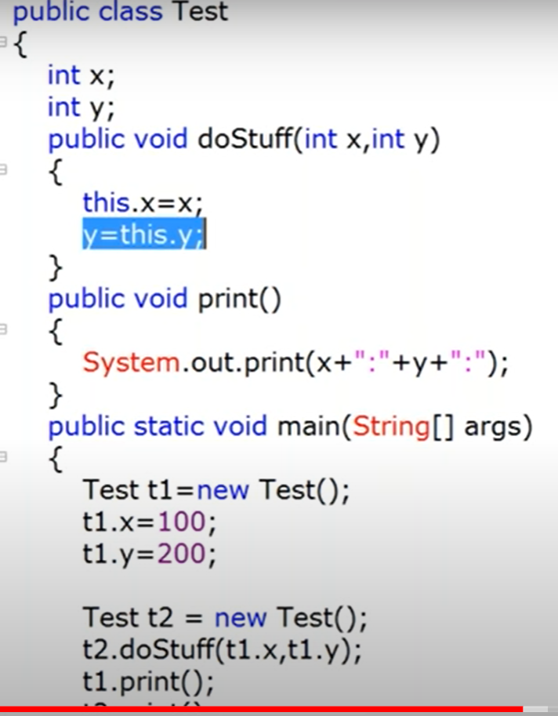

T2.print();

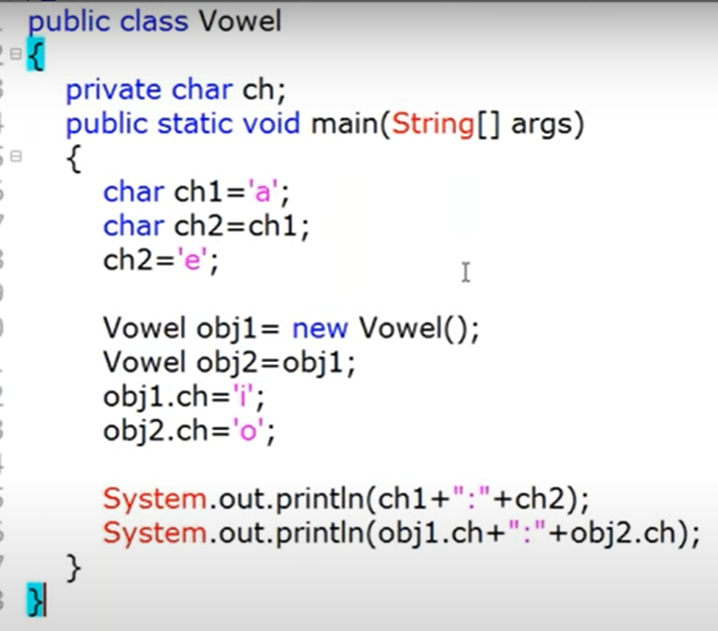

A e

O O

**Main Method and commands Line Arguments**

**Class Test**

**{**

**Public static void main (String [] args)**

**{**

**}**

**}**

**Change in syntax allowed by JVM**

1. Change in order of modifier

**Class Test**

**{**

**static Public void main (String [] args)**

**{**

**}**

**}**

1. String [] args

String []args

String args[]

1. args 🡺 durga
2. String… args
3. Final, synchronized , stricfp

**Tutorial 17:**

//Change in syntax allowed by JVM

Main method:

Compiler never going to check the issue with the main method

JVM is responsible to check

Public static void main (String args) {} - invalid

Public synchronized final strictfp void main (String args) {} – invalid

Public static void Main (String… args) {} – invalid

Public static int main (String[] args) {return 10} – invalid

Public final synchronized static strictfp void main (String[].. args) - valid

Public static void main (String[].. args) - valid

public void main (String [] args) {} – invalid

in all cases no compile time error the problem exist on runtime only

IMP: inheritance and overloading class applicable to the main method

**Inheritance and overloading**

Class A

{

Psvm (“parent main”)

}

Class B extends A

{

}

Java B – here main method of A will run

Class A

{

Psvm (“parent main”)

}

Class B extends A

{

Psvm (“child main”);

}

It is valid structure.

If the class doesn’t contain main method

Class Test

{

}

Javac Test.java

Java Test

Error:

Main method not defined in class Test. Please define main method as

Public static void main (String [] args)

RE: NoSuchMethodError:Main

**From 1.7 version Static block will not execute if jvm do not find the main method**

Class Test

{

Static

{

Systemlout.println(“static block”)

}

}

**Command Line Arguments: - to customize behaviour of main method**

Class Test

{

Public static void main (String [] args)

{

}

}

Java Test A B C

Java Test 10 20 - here 10 and 20 both are string

**Tutorial 18:**

Java Test

**Operators:**

Ternary operators => ? :

== operator and .equals() method

Increment and decrement operators:

int x = 10;

int y = ++x;

sop(y);

sop(x);

y = x++;

int x = 10;

int y = ++10;

sop(y); // increment and decrement operator is not applicable for integer values

similary

int y = ++(++x);

final int x = 10;

x++;

sop(x);

char ch = ‘a’;

ch ++;

sop(ch) //b

double d = 10.5

d++;

sop(d); //11.5

increment and decrement operator is not applicable to Boolean variable

byte b = 0;

while (b++ <128)

{

Sop(b); // here type of byte is b so max + value is 127 after 127 🡺 -128 will be the next value

So this loop will keep going on. // infine loop

}

Syntax wise no issue..

A and b

Resul type = max(int , type(a), type(b))

Sop(10/0) // result type – int 🡺 in case of int there is no way to specify infinity so arithmetic exception

Sop(10/0.0) // result type – double = > infinity

Sop(0/0); // result type – int => – Arithmetic exception

Sop(0/0.0); // result type – double - output - undefined for int type NaN (not a number)

Arithmetic Exception 🡺 Runtime exception but not compile time exception

Possible only in Integral arithmetic but not in floating point arithmetic

/, % only for this operator we will get arithmetic exception

**String concatenation operator(+):**

** The only overloaded operator is “+”

** Java support operator overloading ? No.. only for “+”

Where + act as addition operator or when string concatenation operator

String a = “durga”;

Int b = 10;

Int c = 20;

Int d =30;

If any one of the two are string then + act as concatenation otherwise + operator

Sop(a+b+c+d) // durga102030

Sop(b+a+c+d) //10durga2030

Sop(b+ c+ a+ d) //30durga30

Sop(b+ c+d+a) //60durga

Relational Operators (<, <=, >. >=)

Sop(10<20); // true

Sop(10<10.0)// false

Sop(true<false) // not allowed

Sop(10<20<30) // invalid.. relation operator is only applicable between two variables onl y

**Tutorial 19:**

Sop

**Equality operator**

**== !=**

10==20 // t rue

‘a’ == 10 // true

‘a’ ==97 // true

10.0 == 10.0

false == false // true

10.0f ==10.0 // true

We can equality operator for the object references also

R1== R2 🡺 true if they are pointing to same object

Thread t1 = new Thread();

Thread t2 = new Thread;

Thread t3 = t1;

Sop(t1==t2); // false

Sop(t1==t3); // true

Two object and three reference variables

If the both reference point to same object

R1 == r3 // true

Special case

String s1 = new String (“durga”);

String s2 = new String (“durga”);

Sop(s1==s2) // false as both the object is point to different object even though

the value is same

**Note: in order to apply equality operator there should be relation between two object**

**Object should be same or should have child to parent or parent to child relation**

Object o = new object();

String s = new String (“durga”);

Thread t = new Thread();

Sop(o == s ) // false

Sop(s == t); // false

Sop(t == s); // incomparable types: thread and string

**Difference between == operator and .equals( ) method**

== reference comparison

.equals() - method for content comparison

String s1 = new String(“durga”);

String s2 = new String(“durga”);

S1==s2 // false - because reference Is different

S1 .equals() s2 // true - because content is same

String s1 = new String(“durga”);

StringBuffer s2 = new StringBuffer(“durga”);

S1==s2 // incompatible error… there is no relation for string and string buffer

S1 .equals() s2 // true - because content is same

GOTO – 31:00

instance operator – object is given type or not - atleast should have parent child relation

Thread t = new Thread();

Sop(t instanceof Thread); // true

Sop(t instanceof Runnable); // true

Sop(t instanceof Object); // true

Sop(t instanceof String); // false – there should be some relation between

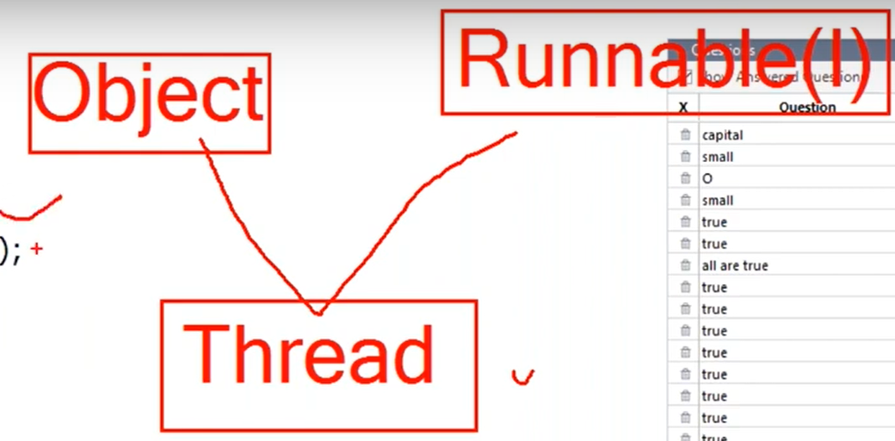

Thread is of runnable type or object type.

Instanceof operator:

= = operator and equals() method wrt string objects

Bitwise operator:

**& 🡺 both argument are true then it write true**

**| => any of the arguments are true then it write true**

**^ 🡺 NOR exclusive X-OR if one argument is true or another is false or vice versa then it writes true otherwise false**

**Sop(true & true) - true**

**Sop(true | false) - true**

**Sop(true ^ false) - true**

**Sop(true ^ false) - false**

**Tutorial 21:**

Sop(true ^ false) - false

Sop(“5 + 2 = ” + 4 + 3) // 5+2 = 43

Sop(“5 + 2 = ” + (4 + 3) ) = 5+2 = 7

Sop(“5 + 2 = ” + (4 )+ (3) ) = 5+2 = 43

Int x = 100;

Int a = x++;

Int b = ++x;

Int c = x++;

Int d = (a<b)? (a<c)?a : **(b<c) ? b:c**:x

Int d = x // 103

Sop(d);

Int x = 1;

Int y = 0;if (++x > ++y)

{

Sop(“Hello”);

}

Else

{

Sop(“Hi”);

}

Sop(“ Durga ” +x + “ : ”+ y); hello durga 2 1

Student s1 = new student(101, “Durga”);

Student s2 = new student(101, “Durga”);

Student s3 = s1;

Boolean b1 = s1==s2; // false

Boolen b2 = s1.name.equals(s2.name); // true

Sop(b1 + “:”++b2); false+true

**GOTO – 55:00**

Int a,b,c,d;

A = b= c = d = 20;

A+=b -+c *=d/=2;

Sout(a + “..”+b +”..”+c+ “..”+d;

First

D /=2;

D = 20/2

D = 10

Second

C*=d

C = 20*10

C = 200;

Third

B = b-c

B = 20-200

B = -160

Fourth

A = a+b;

A = 20 -180

A = -160

Ans: -160..-180..200..10

**Conditional operator ( ? : )**

Nesting of conditional operator is allowed

**Tutorial 21:**

Nesting of conditional operator is allowed

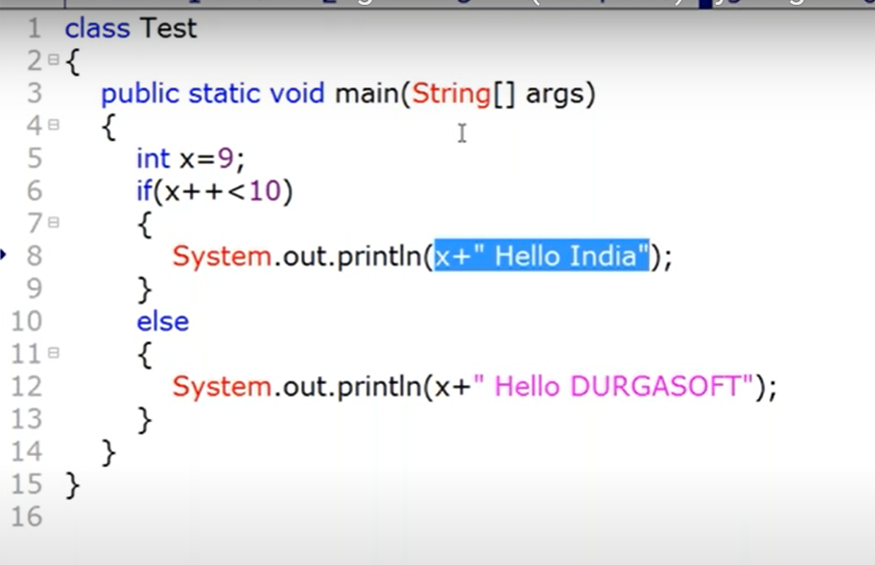

Must execute it to find answer

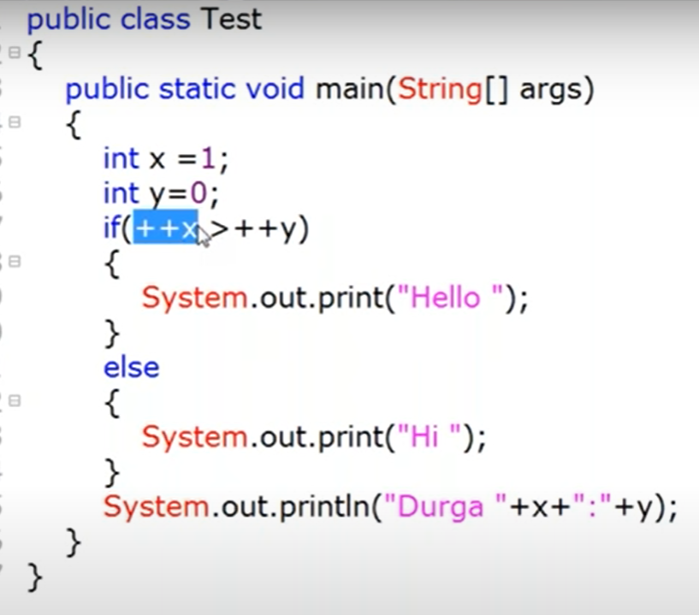

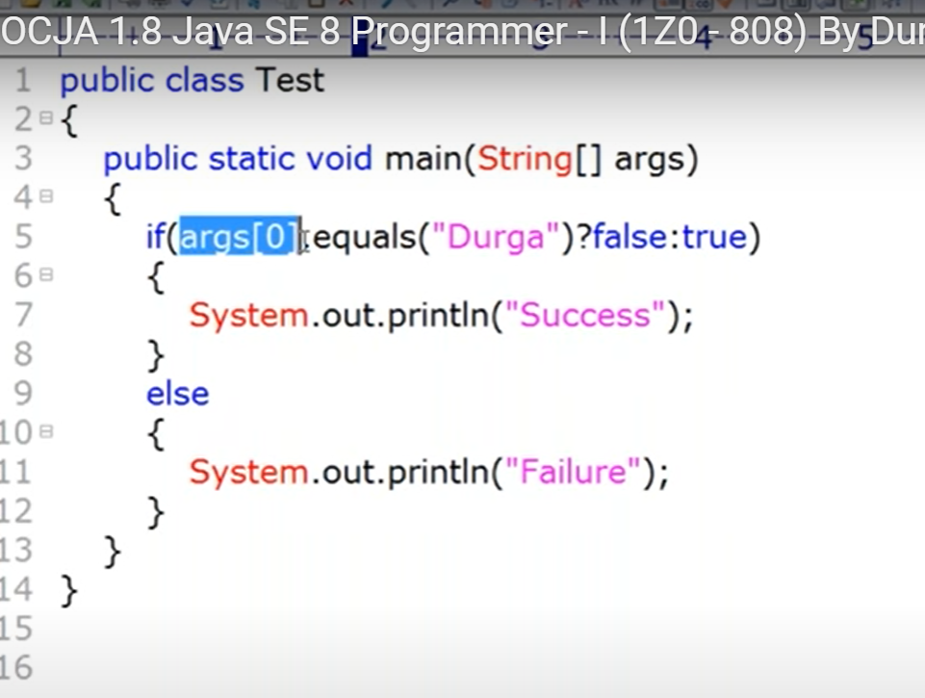

Cmd : Java Test

Mus execute if we don’t pass any arguments

**Tutorial 22:**

Mus execute if we don’t pass any arguments

**Flow Control:**

**Selection statements :** if else , switch statement

**Iterative statement :** while, dowhile, for, for-Each

**Transfer statements :** break, continue, return, try-catch-finally, assert

Note: except switch statement curly braces “{}” is optional

For switch statement - int, char, byte, enum, short, string is allowed as an argument as a datatypes

**Long, double, float , Boolean is not allowed as an argument in switch satatment**

**Case variable must be constant , it does not allow variable**

Int x = 10;

Int y = 20;

Switch(x)

{

Case 10: // allowed case statement as case variable is constant

Sop(10);

Case y : // not allowed case statement as case variable is variable

Sop(20);

}

Case 2 :

**Byte b = 10;**

**Switch(b)**

{

Case 10;

Sop(10);

Break;

Case 100;

Sop(100);

Break;

**Case 1000; // this case is not allowed as range 1000 value is above the range of byte varialble b. which is argument in switch;**

**Sop(1000);**

}

**Imp example**

int x = 1;  
  
switch(x)  
{  
 default :System.*out*.println("default");  
  
 case 10:  
 System.*out*.println("case 1");

break;  
  
}

ans : x = 1 ; ans – default case 1

x – 10 ; ans – case 1; // here default will not be considered

**Tutorial 23:**

// x – 10 ; ans – case 1; // here default will not be considered

while - if we don’t know the number of iteration

for - if we know the number of iteration

for ( A ; B ; C ) –

A – initialization

B – conditional check // default value is true and is compulsory

C – increment

Int I = 0;

For(sop(“Hello Boss”); i<3; sop(“boss you are sleeping”))

{

I++;

}

**Output:**

**Hello Boss**

**boss you are sleeping**

**boss you are sleeping**

**boss you are sleeping**

**Enhanced For loop – only applicable to arrays or collections**

For (int a : x)

{

Sop(a);

}

Some requirement:

1.n process all the elements of the array in the order of entry (for each and for loop)

2. process all the elements of the array in the reverse order of entry (for loop)

3. process alternative elements of the array in the order of the entry. (for loop)

**Tutorial 24:**

//Process

**Break:**

1. Inside switch to stop fall through
2. Inside loop to break loop execution based on some conditions
3. We can used inside labeled block to break block execution

Psvm

{

Sop(“Hello”);

|1:

{

System.out.println(“Begin”);

If(x ==10)

Break |1;

System.out.prinln(“End”);

}

Sop(“Hiee”);

}

Instance block – executed automatically when we create a object

public class One  
{  
  
 {  
 System.*out*.println("Hiee i am instance block");  
 }  
   
 public static void main(String[] args)  
  
 {  
 new One();  
   
 }  
}

labelled block: we need to execute manually

package com.OCJA.Practise;  
  
import java.util.Arrays;  
  
public class One  
{  
  
 {  
 System.*out*.println("Hiee i am instance block");  
 }  
  
 public static void main(String[] args)  
  
 {  
 int x = 1;  
 System.*out*.println("Hello");  
 one:  
 {  
 System.*out*.println("Inside labelled block");  
 break one;  
 }  
 System.*out*.println("Hiee");  
 }  
}

**Continue: -** can be used only inside loop

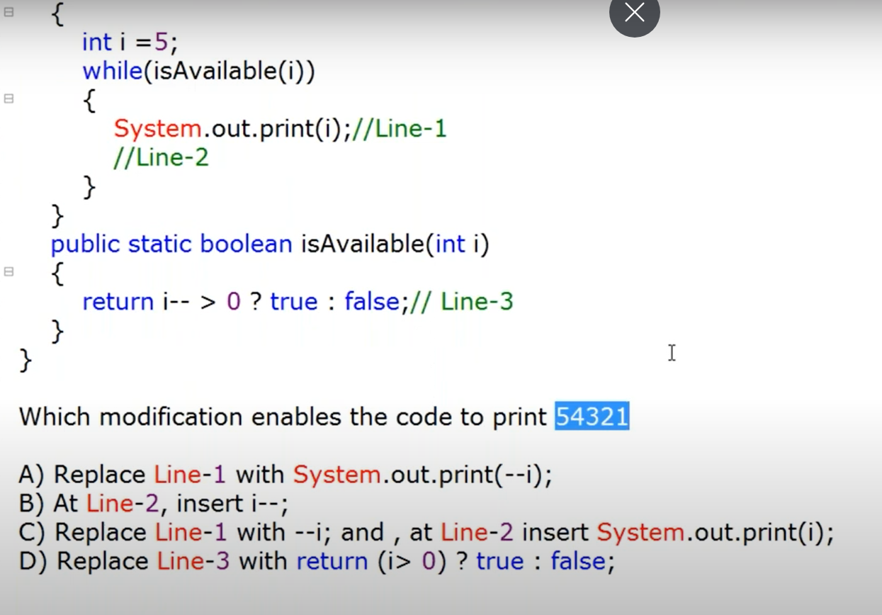

All options are wrong

Correct answer At line 2, insert i--, line 3 return (i>0) ? true: false

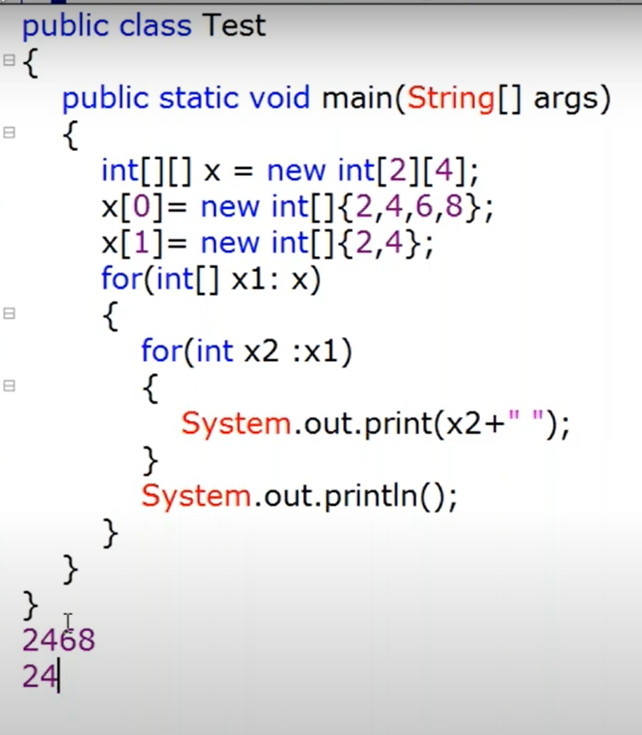

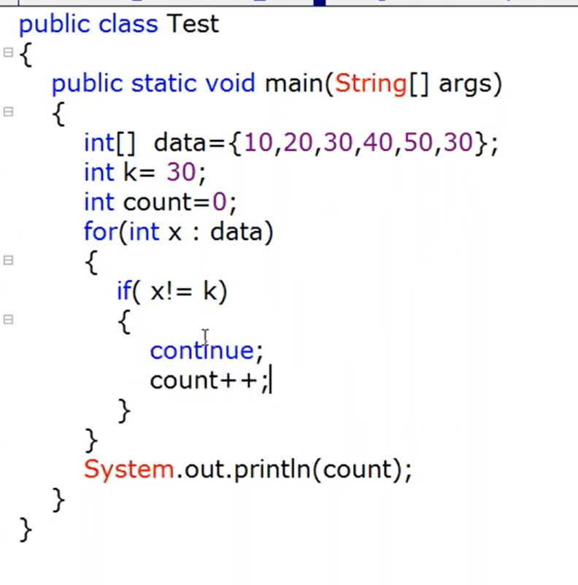

Here count is never reacheable .. so it is compile time error

**Tutorial 25:**

Here

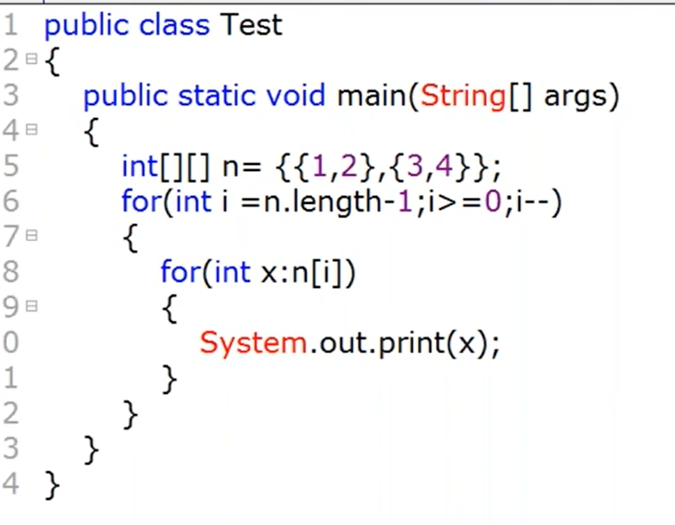

Ans: 3412

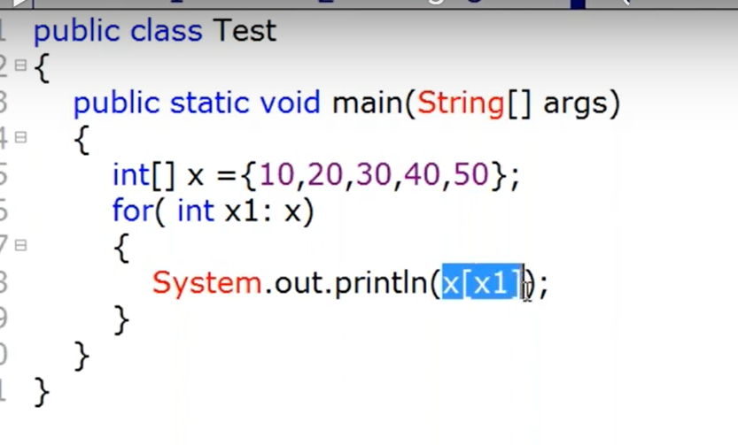

Try this one..

Here value of x1 will be replaced in x[x1]

First value is x[x1] – x[10] – which is index out of bound exception

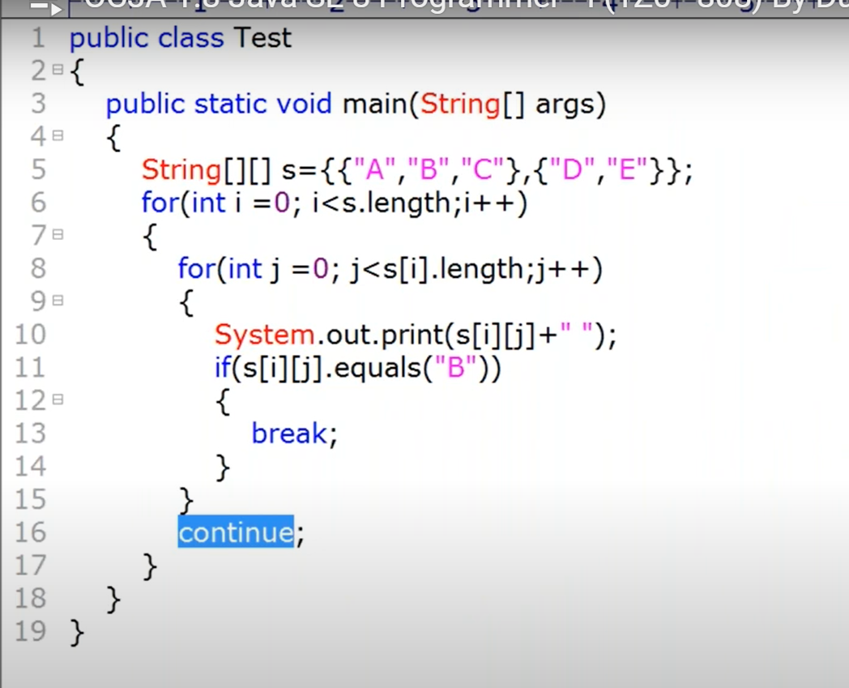

Import questions: please solve manually then on intellij

**Tutorial 26:**

Import questions: please solve manually then on intellij

**Java Source file structure**

Import statement.

Package statement.

Access modifier (public , private, protected and default)

Abstract modifier

Interface

single file can contain number of classes

and the name of the file is depend of the public class in that file

single file can’t contain more than one public class

single file has more than one class but no public class then we can any take name of any class to the file.

Atmost one public class can be present in a single file.

--

If there are multiple non public classes

Suppose A B C and D classes are there

A B contain main class and C D doesn’t contain main classes

Still we can give file name to the C and D classes

And .class file will be generated for each class

If we try to run java A - for class A, then main method of class A will be executed

If we try to run java D - for class D, as it doesn’t have main method , it will give error

GOTO – 42.54

There are two type of import statement

1. Explicit class import statement - import.java.util.AssertList
2. Implicit class import statement - import.java.util

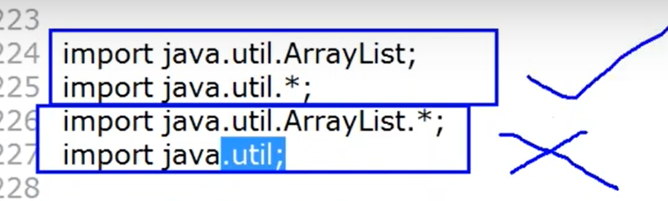

Which classes are meaningful import classes

1, 2 are meaningful import

3,4 are not meaningful import

Always use explicit import is highly recommended.

Performance wise both they types are equal

**Tutorial 27:**

//Performance wise both they types are equal

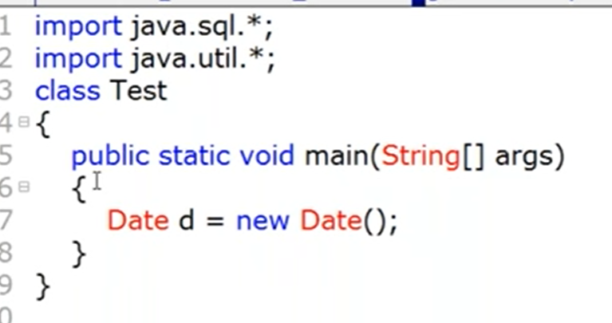

Both import statement contain date class so at run time it give **compile** time error

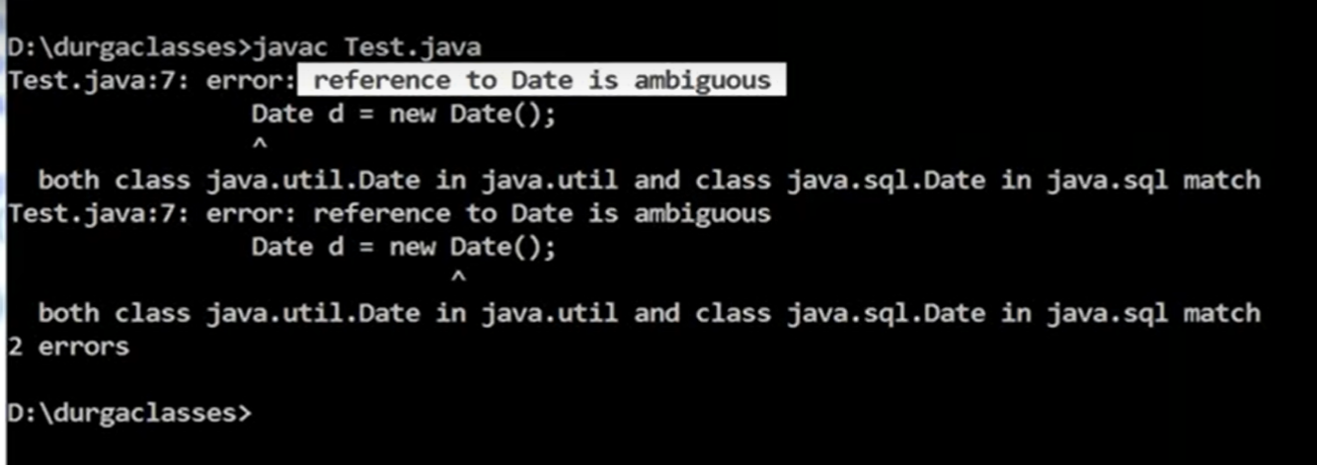

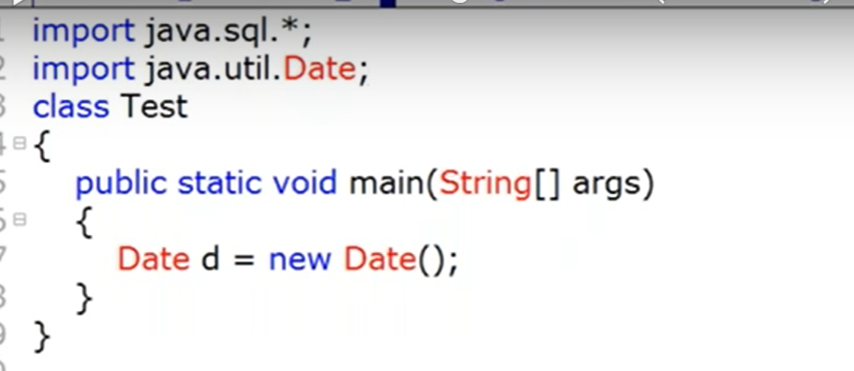

Here we have used explicit import for date. So it will not give compile time error

And compiler will use util.date class while compilings

While resolving class name how compiler will give precedence ?

Date : 🡺 util (explicit) (Highest/ first priority to explicit class)

Date:🡺 current working directory (second priority goes to CWD even the import statement is not there)

Date:🡺 sql(implicit) (last priority)

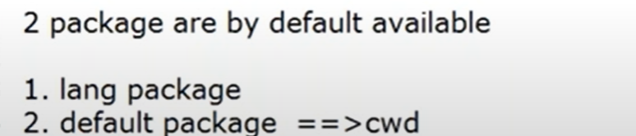

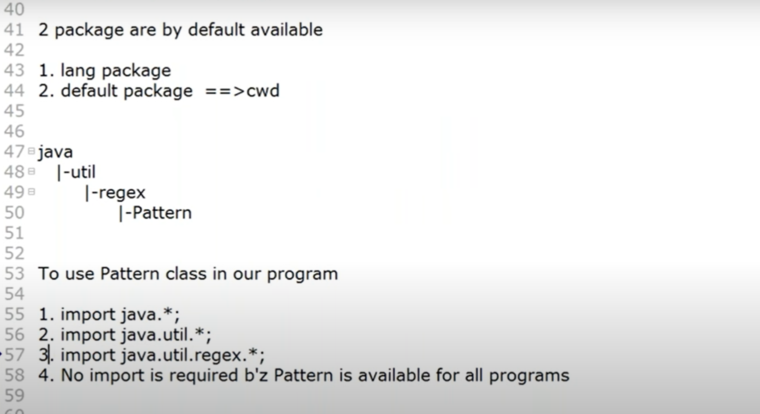

Ans – 3 for sub package we need to import till the subpackage, only main package import doesn’t work

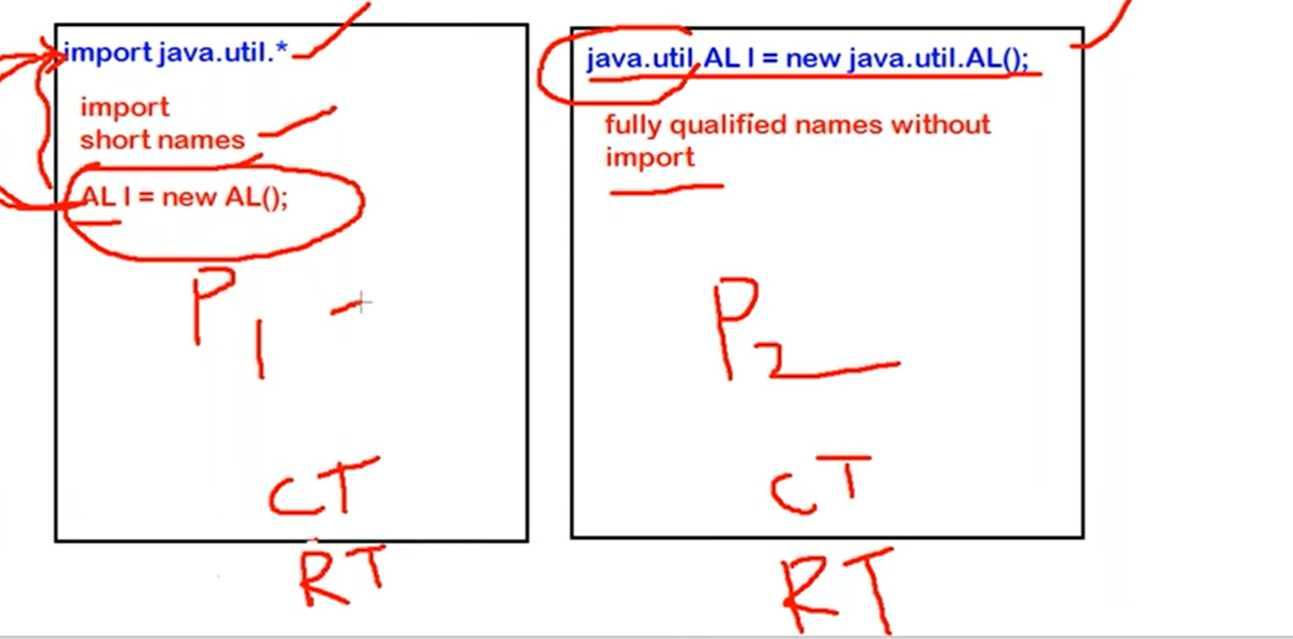

For RT both takes same time

For CT P1 will take more time than P2

For static import

We can add static import java.util.lang.Math; then instead of Math.sqrt() we can directly use sqrt();

**Tutorial 28:**

Package – it is group of related things

Class and interface encapsulated into single component is called package

1. Modularity of application
2. Naming conflicts
3. We can achieve security for our components – using modifier for class

Unique identification : internet domain

Ways to create package

Com.iccibank.loan.housingloan.Account

Account - class name

Housing loan - submodule of loan

Loan- main module

Com.iccibank – domain of the bank.

To generate a .class file in the particular package

Javac -d . Test.java – this is used to genereate a .class file in destination

Javac Test.java - .class file will be generated at current directory

Javac -d . Test.java if the package is present in the class then .class file will use the same package or otherwise will create it.

If we want to create a class file at a particular location then

Javac -d E: Test.java - it will create a .class file at E/com/durgasoft/ocja

To run the .class file

Java com.durgasoft.ocja.Test – to run the .class file we need to use prequalified name

**Conclusions for OCJA Exam:**

1. **Atmost** one package statement is allowed
2. **Package must be first non commeted statement in the .java file**

**Java source file structure – order is important**

Package statement – atmost one

Import statement - any number

Class or interface or enum declaration – any number including zero

Java source file with only package or only import without class interface is a valid source file.

Modifiers – describe the behavior of the class

Public Class Test

{

}

Total Modifier are in java

Public

< default >

Private

Protected

Static

Abstract

Strictfp

Final

Synchronized

Native

Volatile

Transient

For top level class. Only applicable modifier are (5 modifiers are allowed)

**Public, default abstract strictfp final**

For inner classes just 8 modifiers are allowed

**Public, default abstract strictfp final**

**Private protected and static**

For OCJA

Public

Default

Private

Protected

Abstract

1. Public - we can access from within or outside the package
2. Default - we are allowed access within package only
3. Final – class must have implementation

Applicable for classes method and variables

Final variable - can’t change value

Final method - can’t override this method.

1. Abstract : applicable for method and class

Means only declaration and not implementation

Final synchronized static private strictfp – must talk about implementation

abstract class : partially implemented class is kown as partially implemented class

**it is not possible to create object for abstract class.**

abstract class vs abstract method

1. If a class contain at least one abstract method then we should declare class as abstract

**Tutorial 29:**

//For inner classes just 8 modifiers are allowed

Class Test

{

}

**Tutorial 30:**

//For inner classes just 8 modifiers are allowed

Abstract method

Public abstract void m1() – allowed

Public abstract void m1() {} – not allowed

Abstract class:

Partially implemented

**Object creation is not possible for abstract classes.**

**abstract class vs abstract method**

1. If the class contain at least one abstract method then compulsory we should declare that class as abstract.
2. If the class doesn’t contain zero number of abstract method then also we can declare class as abstract.

Abtract vs final

1. Final method can’t be override, abstract we must override

That’s why final and abstract can’t be use at a same time in method declaration

Statement

1. Final class can contain abstract method – false
2. Abstract class can contain final method - true

**Strictfp:**

Applicable for method and class

Strictfp M1() // floating point arithmetic is very strict independent of platform

{

Sop(10.0/3); //3.333333333

}

Java strictfp keyword ensures that you will get the same result on every platform if you perform operations in the floating-point variable. The precision may differ from platform to platform that is why java programming language have provided the strictfp keyword, so that you get same result on every platform.

It is applicable for inner class also

**Member modifier:**

Member - Methods and variables

1. Public member – anywhere access
2. If method is public but class is not public .. so we can’t access the method from outside of the class.

Default 🡺 package level access

Private 🡺 also know as class level access

Note: private method can’t be abstract and vice versa

So private abstract combination is illegal combination

****IMP

Protected : within the current package and outside the package only in child class.

Protected = <default> + kids

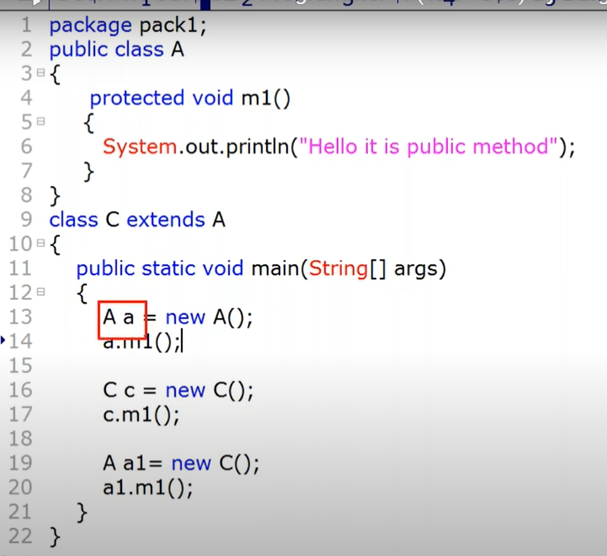

We can access the protected class within the same package - class or outside of the class with child. Also we can access child object with parent reference within same package

We can access class A (parent) (protected class) and child B if they are in **same package** in following ways

A a = new A(); - valid

C c = new C() - valid

A a1= new C(); - valid

A1.m1(); - valid

We can’t access class A (parent) (protected class) and child B if they are in **different package** in following ways.

We can’t access A a protected class outside of the package

Parent reference is not allowed even in child class.

A a = new A(); - not valid

a.m1() – not valid

C c = new C() – valid

A a1= new C(); - not valid

A1.m1(); - not valid

IMP ******

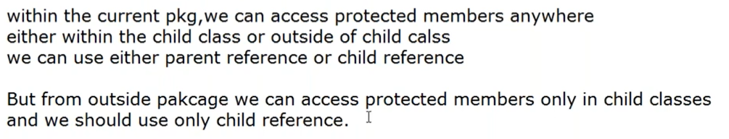

Or its child classes reference

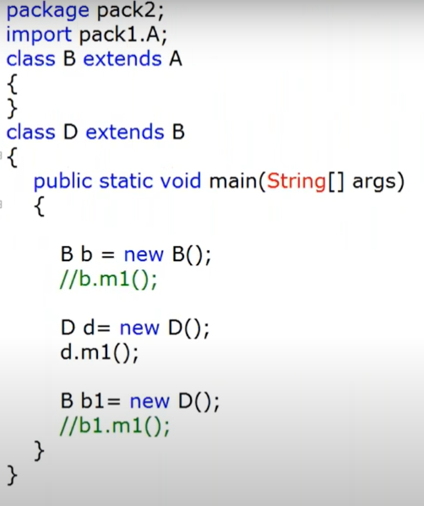

invalid

invalid

invalid

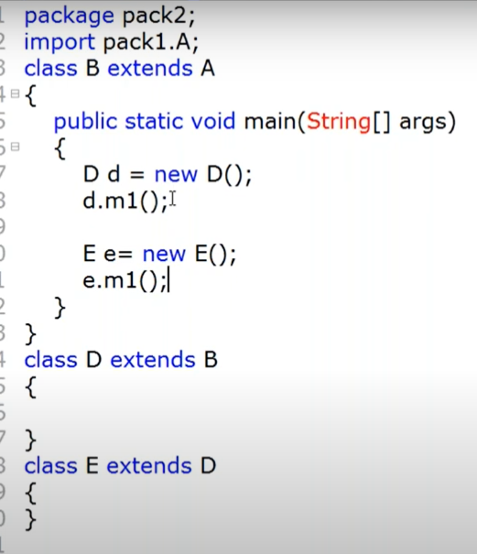

Protected vs abstract

Implementation must be provided for abstract.

Protected not necessary to provide implementation

**Tutorial 32:**

//Protected not necessary to provide implementation

**Interfaces :**

**Tutorial 33:**

//Protected not necessary to provide implementation

**Interface variable:**

Requiremental level constant if we want to define

**Tutorial 34:**

Marker interface – doesn’t have any method , and our object get ability if we implement that interface as jvm provide it

Difference between abstract and interface

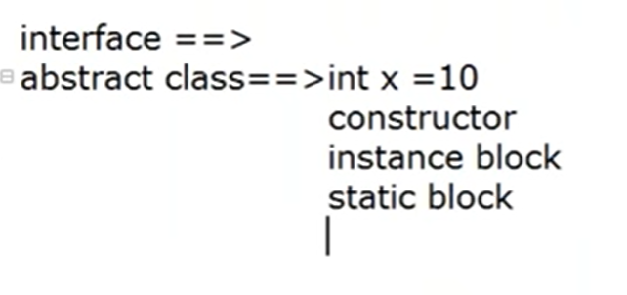

**Tutorial 35:**

// Difference between abstract and interface

**Tutorial 36:**

// OOPS Concept

**Tutorial 37:**

**Tutorial 38:**

IS-A Relationship

Class A extends B

Cyclic inheritance is not allowed in java

Has-A relationship (most commonly used relationship)

Class Test

{

String s = “durga”;

Psvm

{

}

1. In Java, we have two types of relationship: Is-A relationship: Whenever one class inherits another class, it is called an IS-A relationship. Has-A relationship: Whenever an instance of one class is used in another class, it is called HAS-A relationship.

IS-A (Association) vs Has-A (composition/Aggregation)

If I want to extend the functionality then I use IS-A

If I just want to use the functionality then I used HAS-A

Difference between Composition or Aggregation

Strong association - composition

Weak association - Aggregation

Method signature // method name followed by argument type

Public static int m1(int I, float f)

{

}

Method signature – m1(int, float)

F

Method signature followd by argument type

**Tutorial 39:**

**Overloading:**

Have same name and different method argument type then it is overloaded method

Number of argument

Order of argument must be different

Compiler based on reference type

Static polymorphism or compile time polymorphism or early binding

**Tutorial 40:**

Overriding

Method signature must be same

Return type can be different

Co-variant return type – parent child relation of return type

Child – parent is not allowed

Co-variant type is not applicable to primitive type

Not applicable to private method

Overloading

Method signature must be different including order of arguments

**Tutorial 41:**

//Method

RuntimeException and Error are unchecked exception

**Tutorial 42:**

RuntimeException

Polymorphism

C c = new C(); here we can hold child object and also called child object

P p = new C(); - parent reference can hold the child object or any child object but we can access only parent method.

**Tutorial 43:**

object

1. either super or this but not both simultaneously

super() - constructor ();

Test (double d)

**Tutorial 44:**

//object

Inheritance concept: not applicable

**Tutorial 45:**

**Tutorial 46 – 49 Exception:**

**Tutorial 50:**

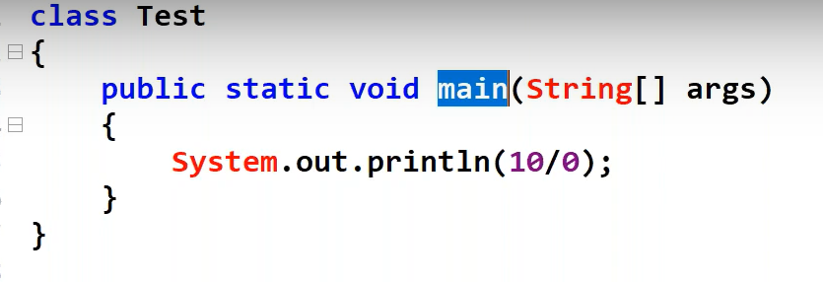

**Step 1: Main method is responsible for creation of exception object**

**Step 2: main method pass that exception object to the JVM**

**step 3: JVM check whether the handling code is present or not**

**step 4: if the handling code is not present then jvm call default exception**

**step 5: Default exception print the description on the console**

**in Throw:**

here we create exception object explicitly and we can handover to JVM manually

**Tutorial 51:**

Customize exception class must extend RuntimeError

Because we don’t want to handle those execption

Rethrowing of exception

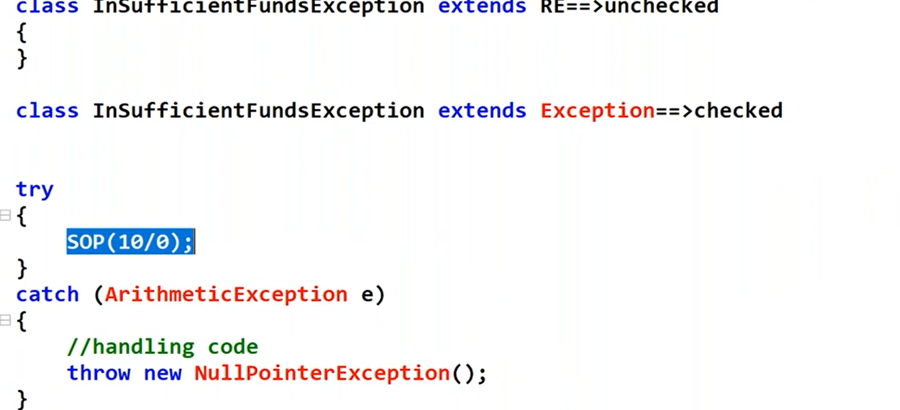

52 – end of exception